

**PROJECT 2.** Mastering Web Vulnerabilities and Network Scanning

**Description:**

This project focuses on practical cybersecurity training by exploring web application vulnerabilities, writing professional reports, solving Capture The Flag (CTF) challenges, and mastering network scanning. It includes hands-on tasks with OWASP Juice Shop and TryHackMe's "Root Me" CTF, enhancing both offensive and defensive skills. Additionally, it incorporates developing a custom Python-based Nmap tool, fostering scripting and network analysis expertise.

**Contents**

**Identified Vulnerabilities**

Vulnerabilities in OWASP Juice Shop **3**

**Nmap**

Nmap scans on the Metasploitable to 10

detect services and vulnerabilities

Developing a custom Python-based Nmap

scanner 11

**TryHackMe**

"Root Me" challenge 18

"Pickle Rick" challenge 24

"Mr. Robot CTF" challenge 32

**GoBuster Universal**

Automation script 41

**Vulnerabilities in OWASP Juice Shop**

### **Steps to Install OWASP Juice Shop:**

* Clone the Juice Shop Repository

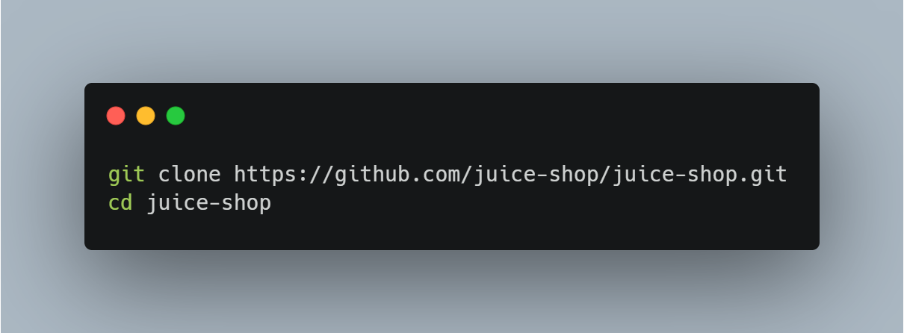

* Run the Docker Command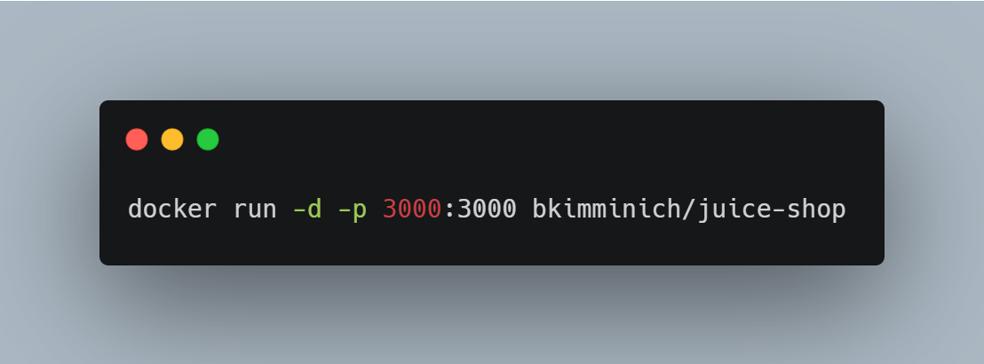

-d: Runs the container in detached mode (in the background).

-p 3000:3000: Exposes port 3000 on your localhost, allowing you to access Juice Shop via <http://localhost:3000>.

* **Access Juice Shop**: Open a web browser and go to

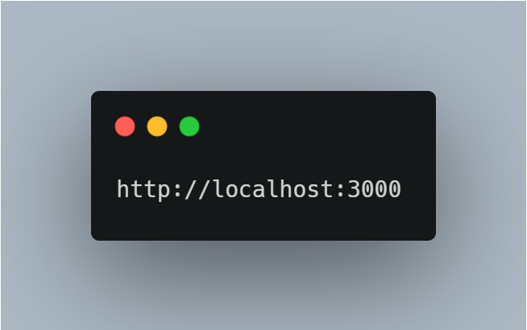

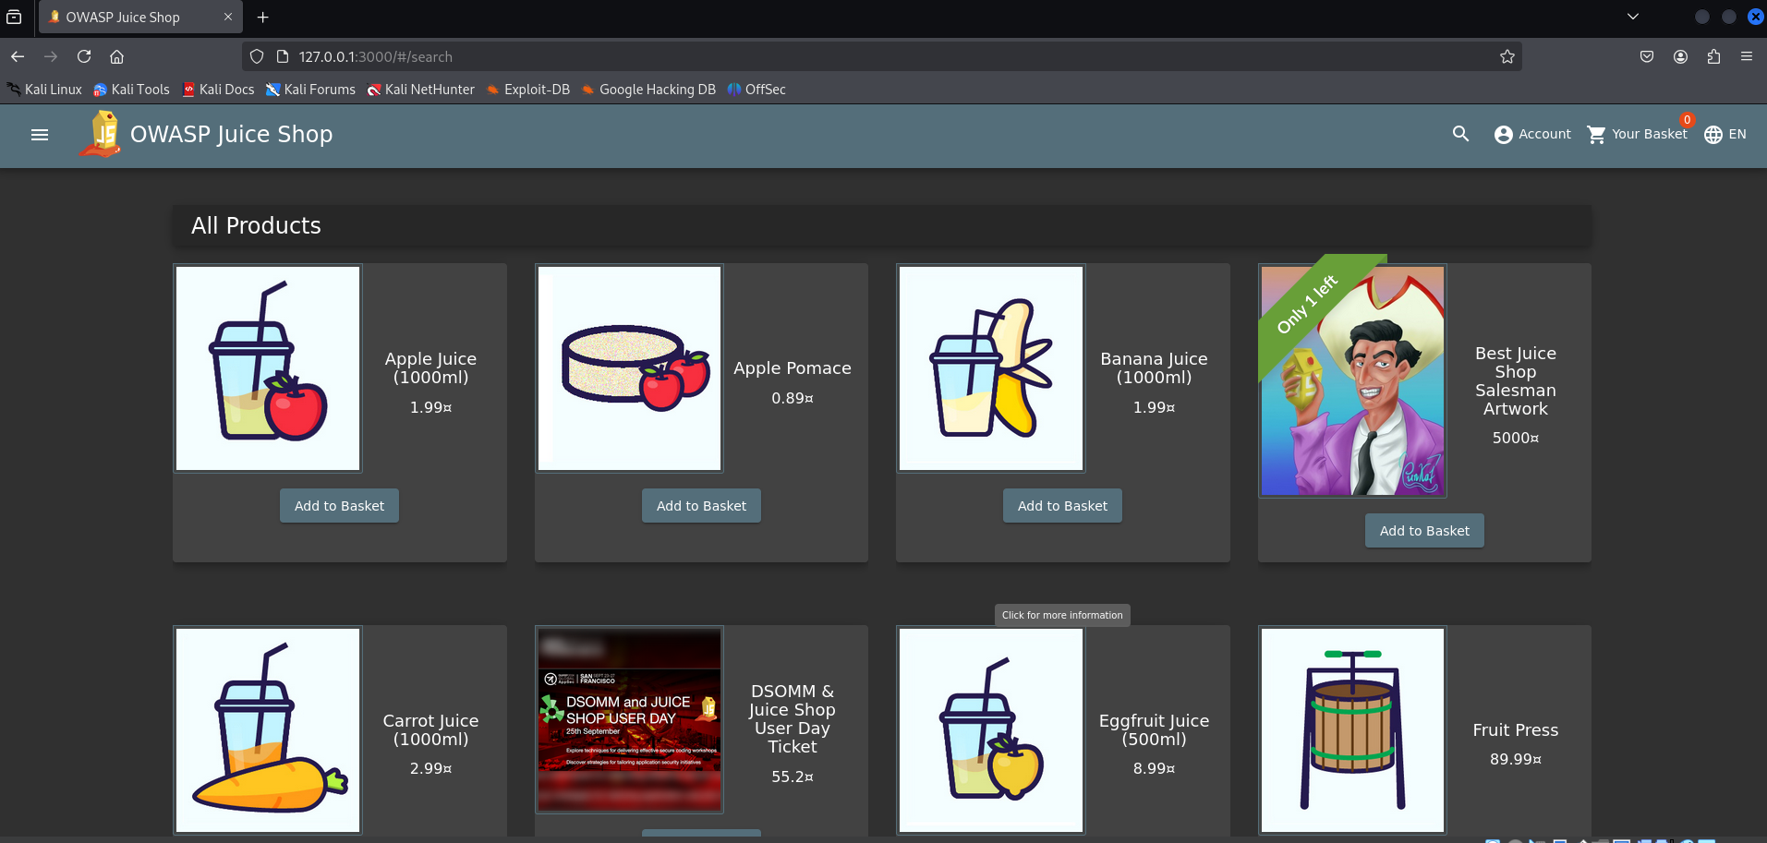

**Broken Access Control**

A broken-access vulnerability was found through which we get an access to the admin's account.

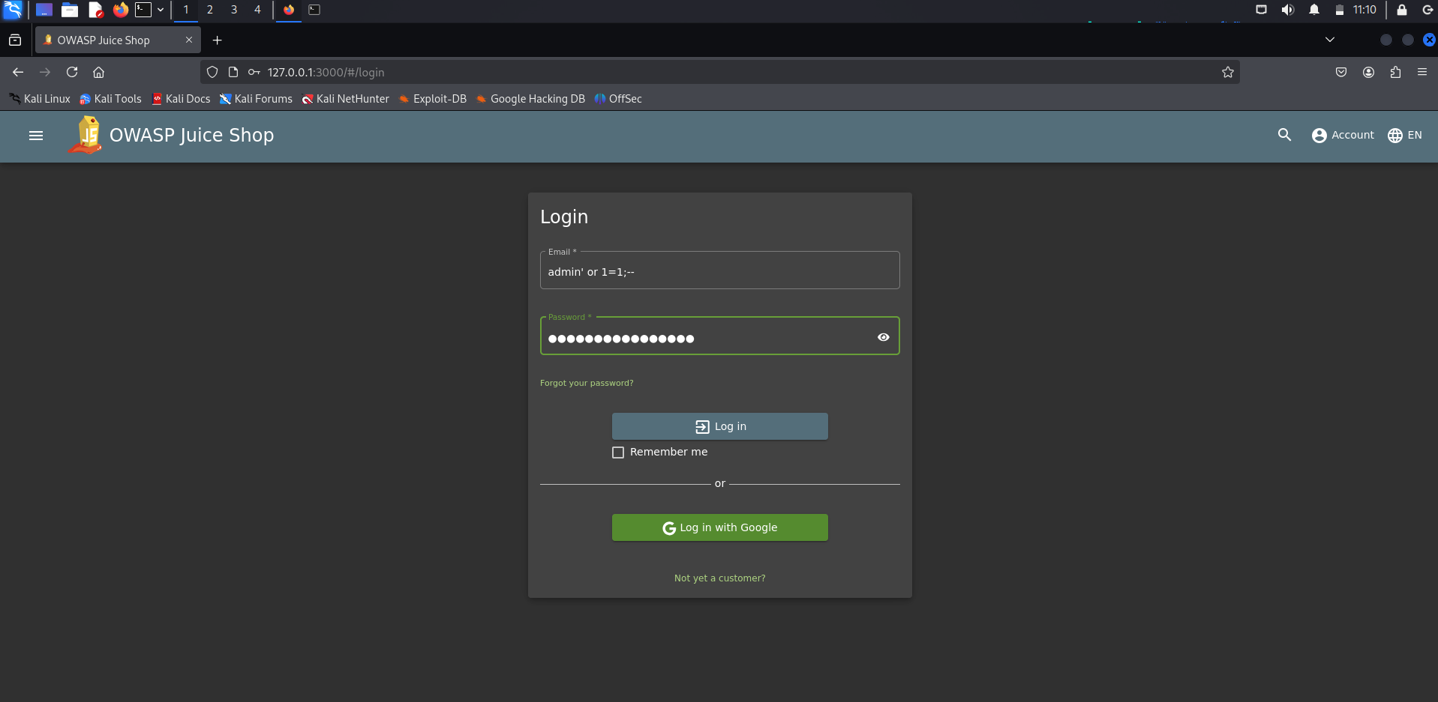

Put the same login and password in order to make the condition become true.

**XSS** Vulnerability

We will cause a simple reflected XSS attack on the Juice Shop application by compromising a parameter value in the URL. First go to Account in the upper right corner, then to Orders and Payment, select Order History**.**

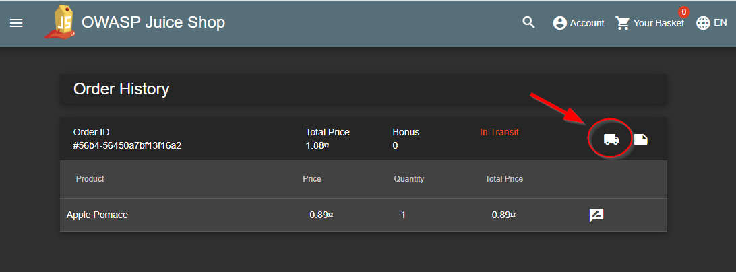

* Click on the truck. This will take you to an expected delivery page with search results. Carefully look at the URI and notice that it is not encoded or using a trusted html link for the parameter value.

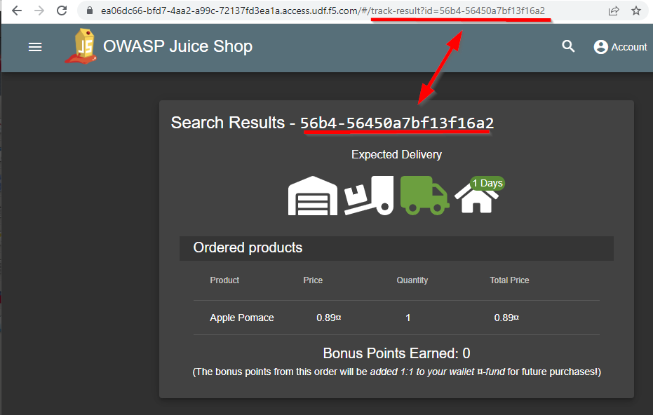

* Paste the following code
* Paste http://127.0.0.1:3000//rest/products/search?q=qwert%27%29%29%20UNION%20SELECT%20id%2C%20email%2C%20password%2C%20%274%27%2C%20%275%27%2C%20%276%27%2C%20%277%27%2C%20%278%27%2C%20%279%27%20FROM%20Users--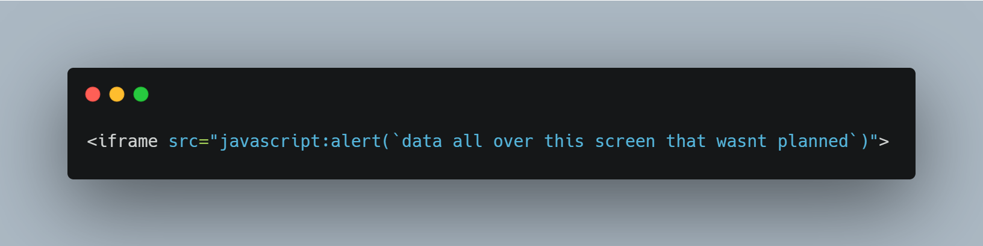

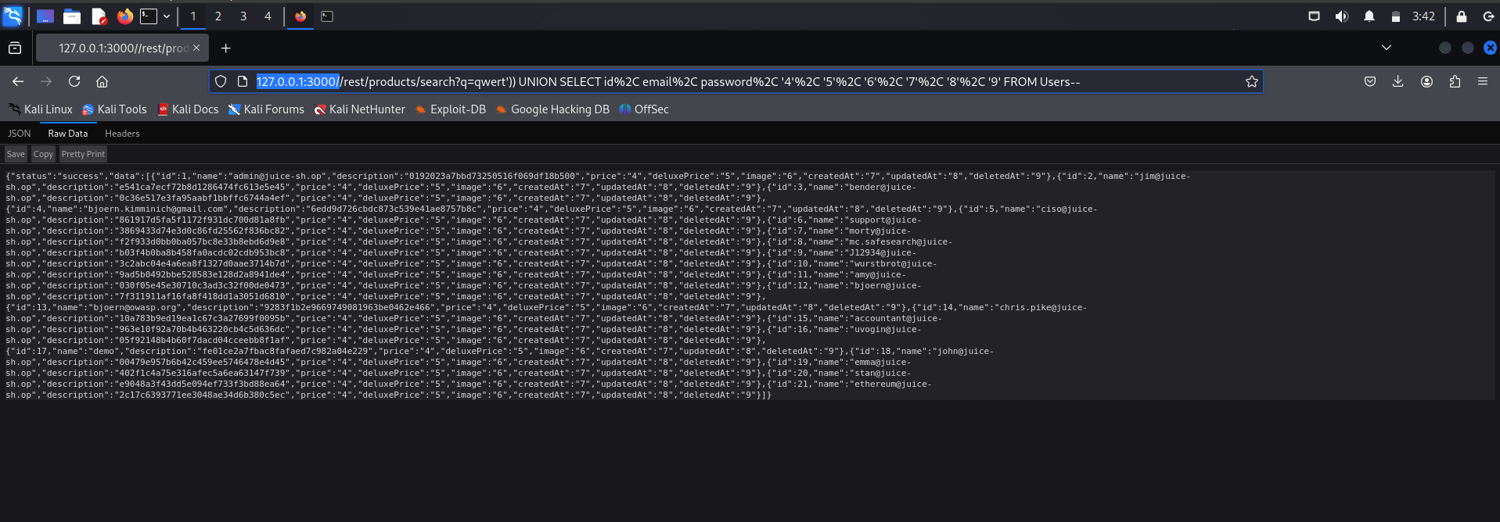

* The result should be a list of all the users in the database including their hashed passwords.
* Use a rainbow lookup table to expose the admin user’s password by navigating to <https://crackstation.net/> and entering the hash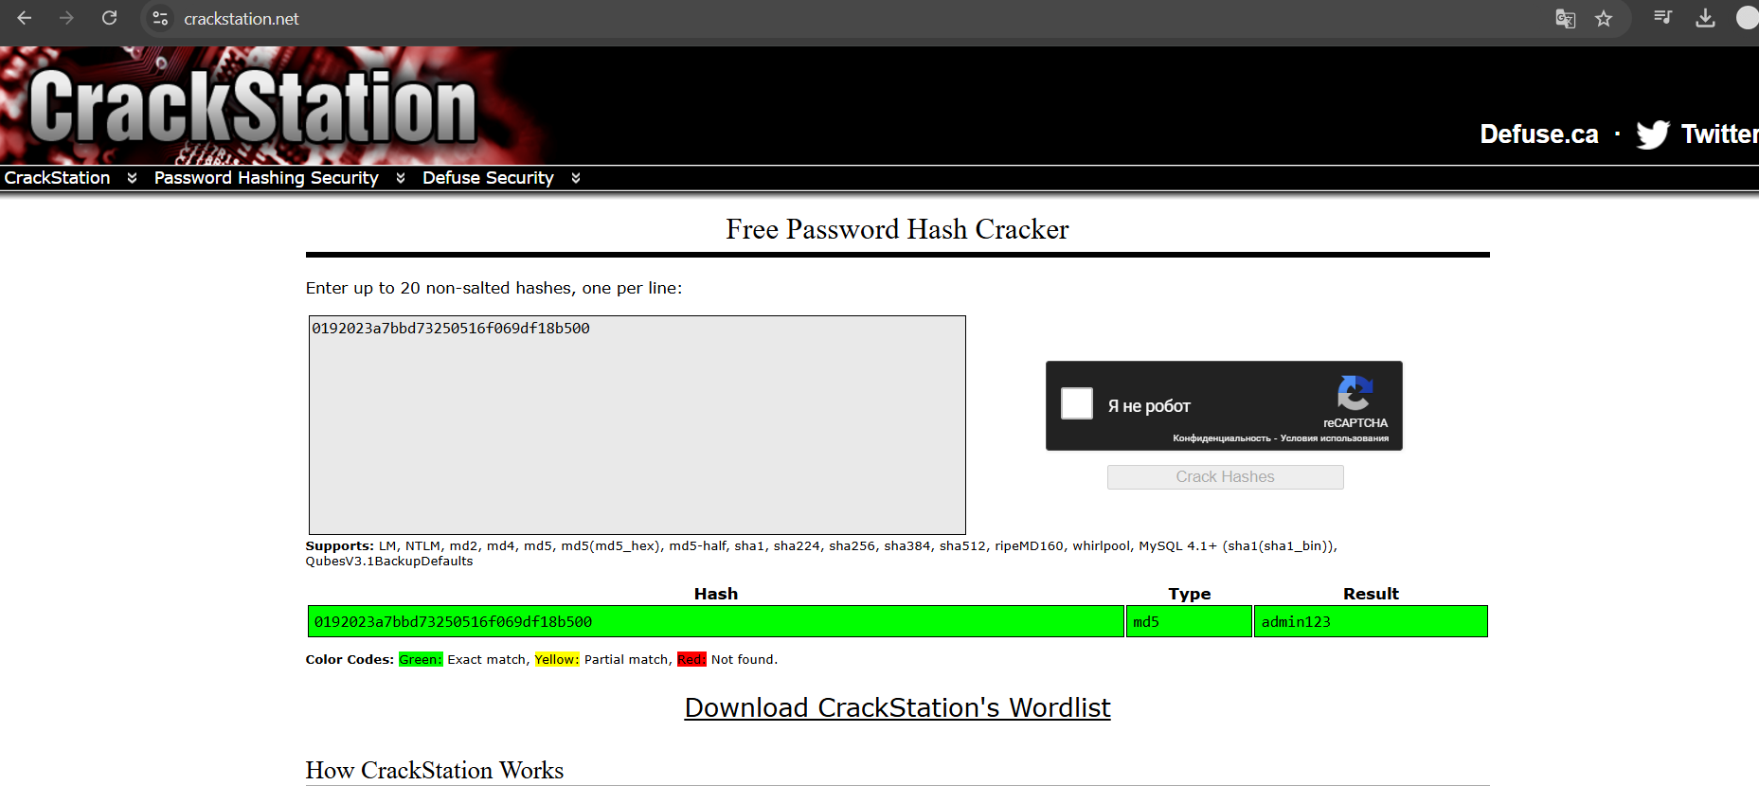
* The pass is admin123

**Error Handling**

Provoke an error that is neither very gracefully nor consistently handled

For the error handling we open the burp, catch the request and do the modification.

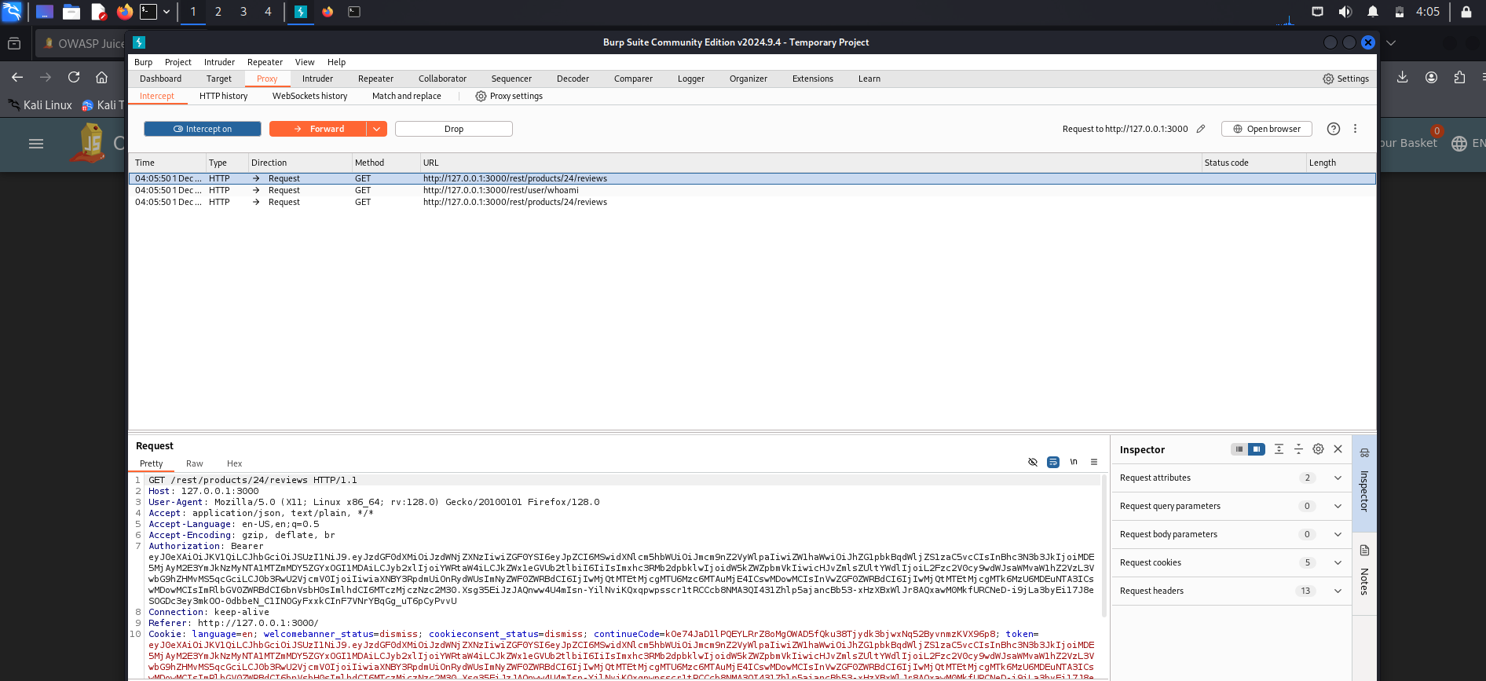

* We send the request to reapeatr

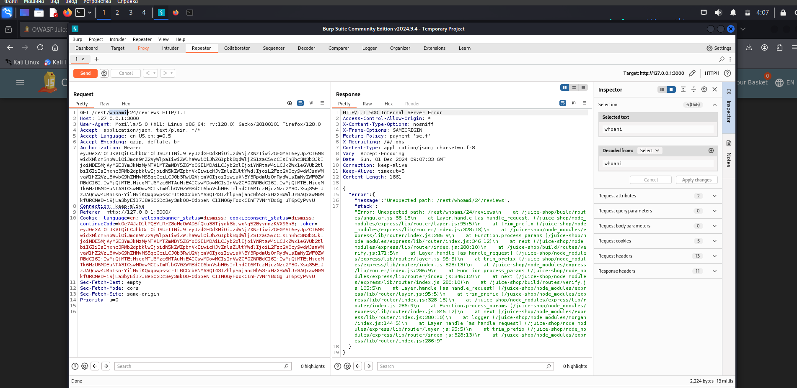

* Then we change the product to whoami and see 500 server error

**Confidential Document**

**We find hidden directories using Dirb**

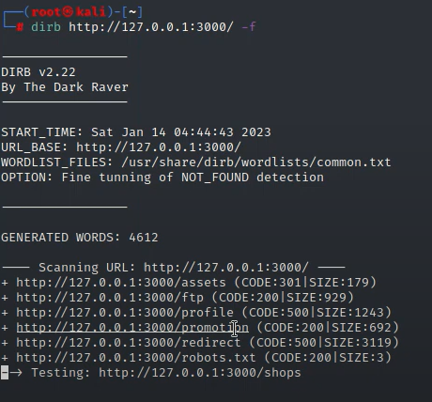

* We found ftp

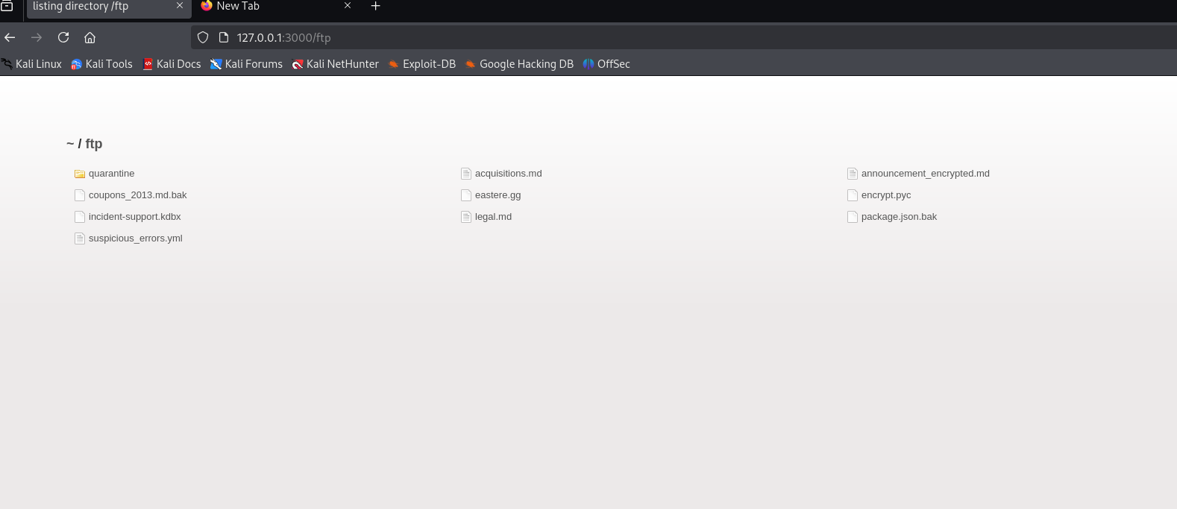

**CSRF**

Then we need to write an HTML code using which we'll change the user's username.

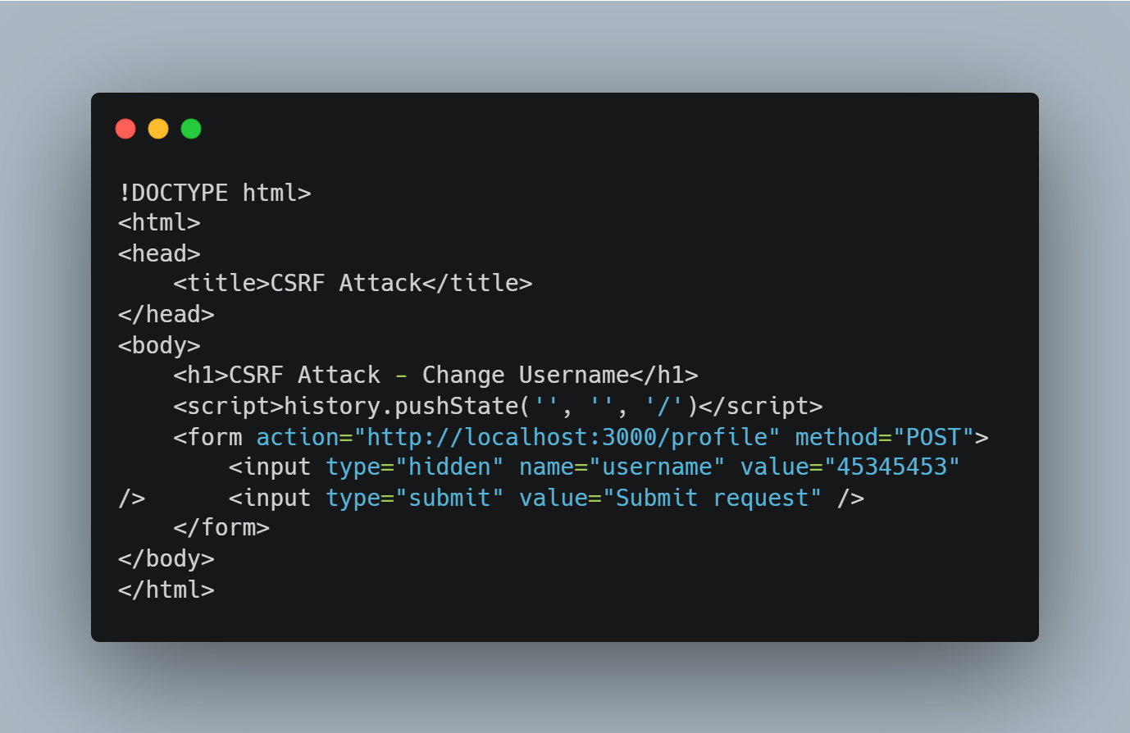

* We open a new window and put the html file in the search field

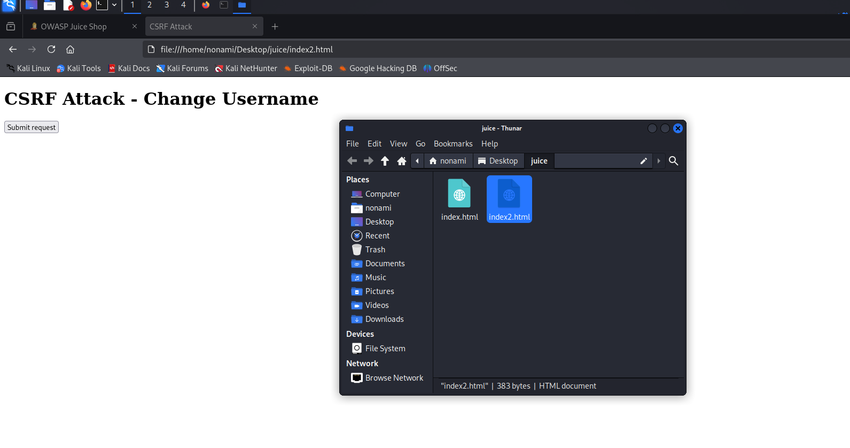

* Then click submit, The username is changed

**Scan Metasploitable with Nmap**

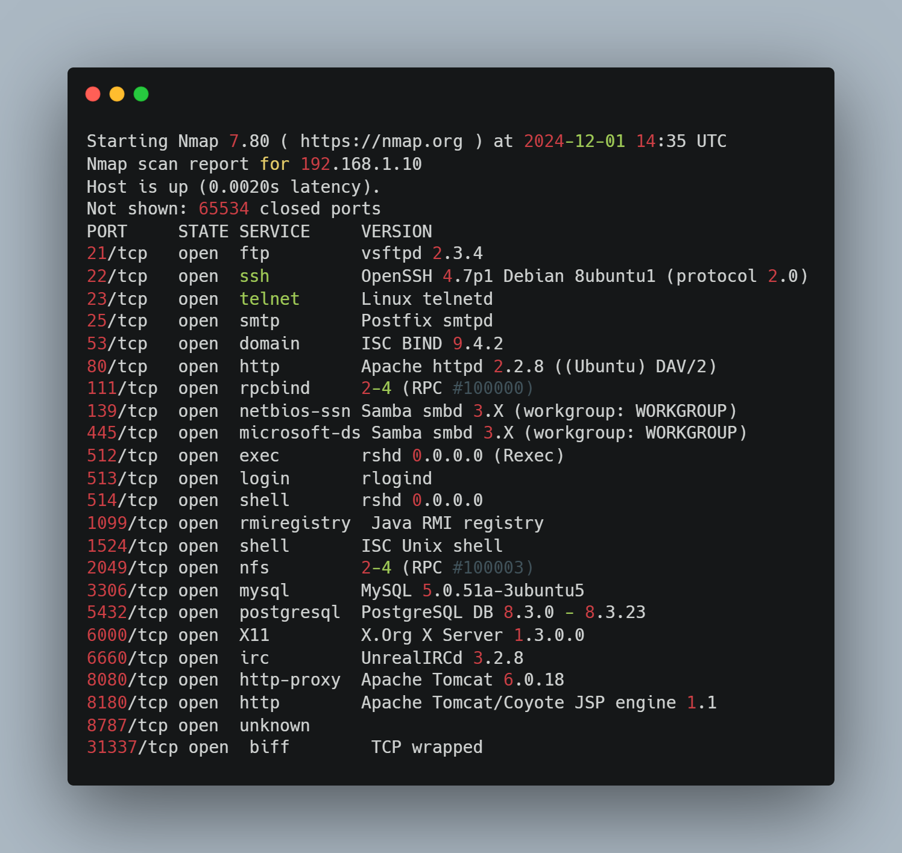

**Python-based Nmap scanner**

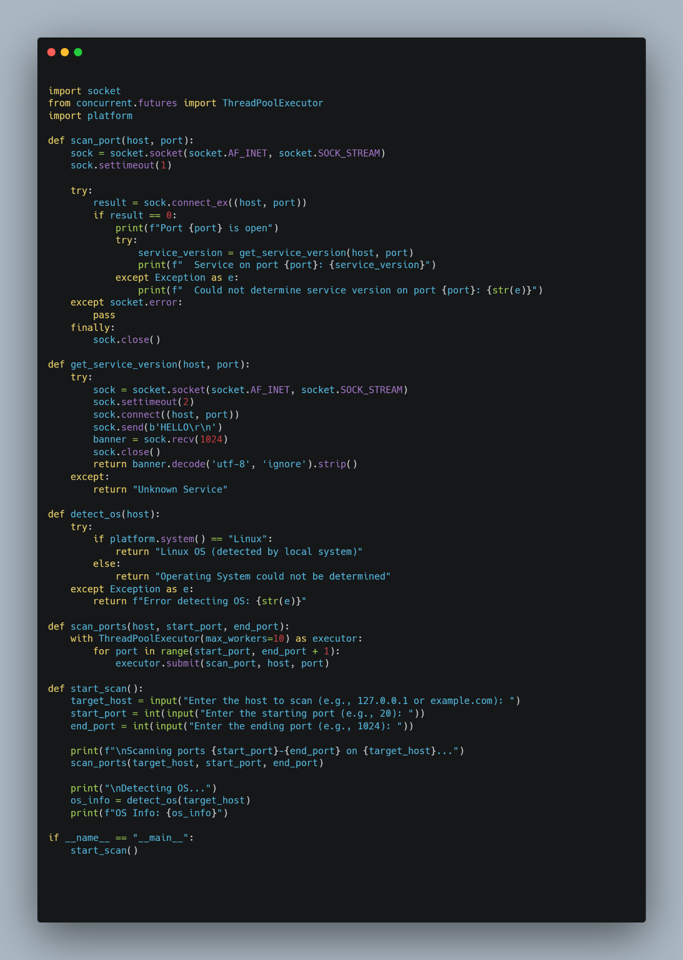

* Import.

**Socket:** This module provides low-level interfaces for handling network connections. It is used to create sockets, connect to remote systems, and check port availability.

**ThreadPoolExecutor:** The concurrent.futures module provides tools for parallel execution of tasks. In this case, it is used to create a thread pool that allows multiple ports to be scanned simultaneously, speeding up the process.

**Platform:** This module provides information about the platform (operating

system). In this code, it is used to define the operating system on which the

script runs.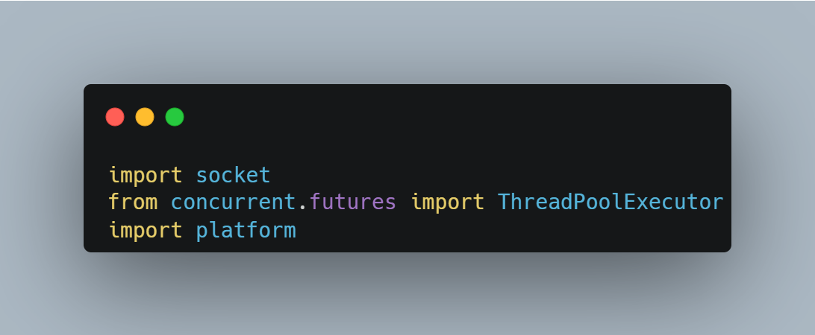

* Function scan_port(host, port)

Socket creation: sock = socket.socket(socket.AF_INET, socket.SOCK_STREAM) creates a TCP socket using IPv4 (AF_INET).

**Timeout:** sock.settimeout(1) sets the maximum connection timeout to 1 second.

**Port check:** sock.connect_ex((host, port)) attempts to connect to the specified port. If the connection succeeds (result == 0), it means the port is open.

**If the port is open:** A message that the port is open is displayed and get_service_version() is called to determine the version of the service running on that port.

**If the port is closed:** A connection error (e.g. port closed) is simply ignored and no information is output.

**Closing a socket:** At the end of a socket operation, the socket is closed to free up resources.

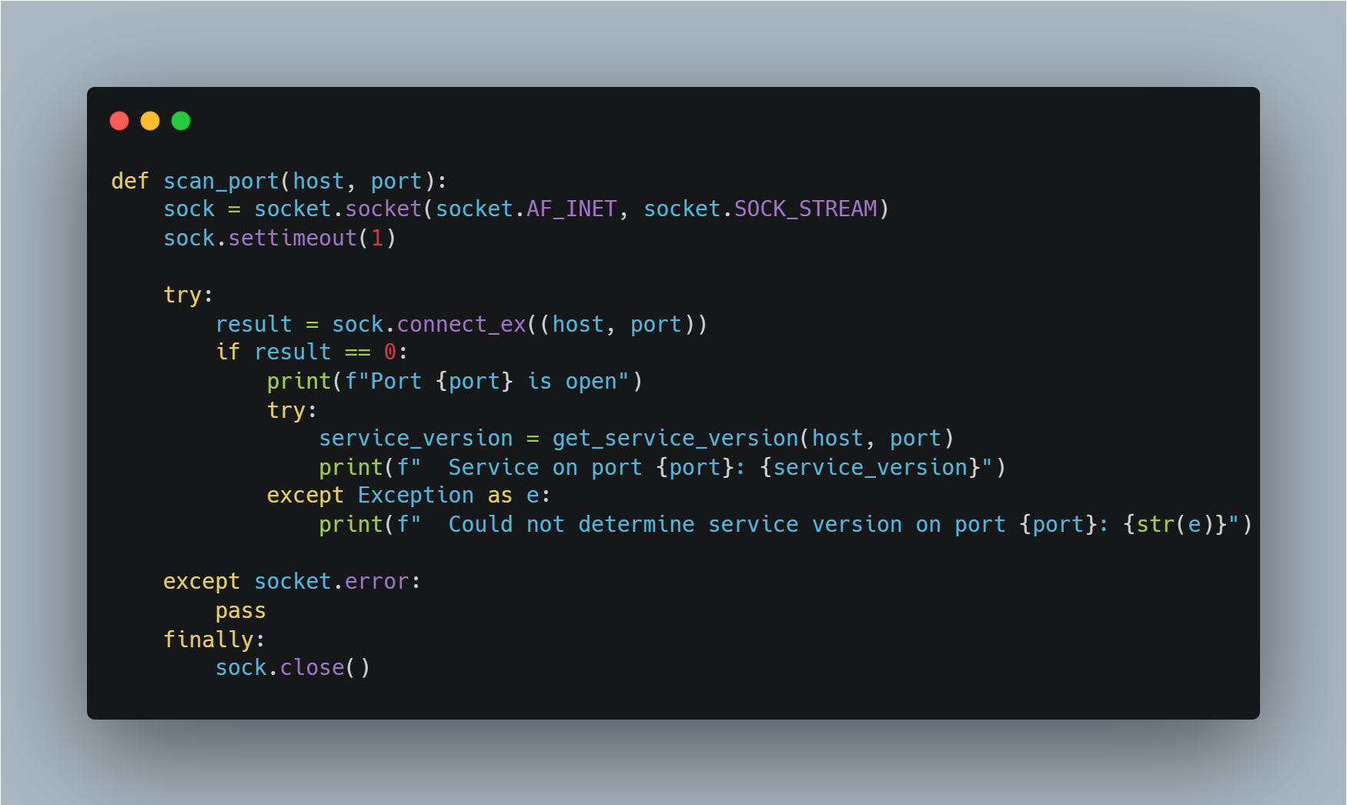

Function get_service_version(host, port)

* **Connecting to a service**: The function attempts to connect to the port and send the string "HELLO". This is often used to get a "banner" - information about a service that is running on the port.

**Getting the banner:** After connecting, a request is sent and then we try to get a response from the server, which usually contains information about the service (e.g. version).

**Error handling:** If an error occurs while connecting or receiving data, the string "Unknown Service" is returned.

**Connection closure:** After receiving data or in case of an error, the socket is closed.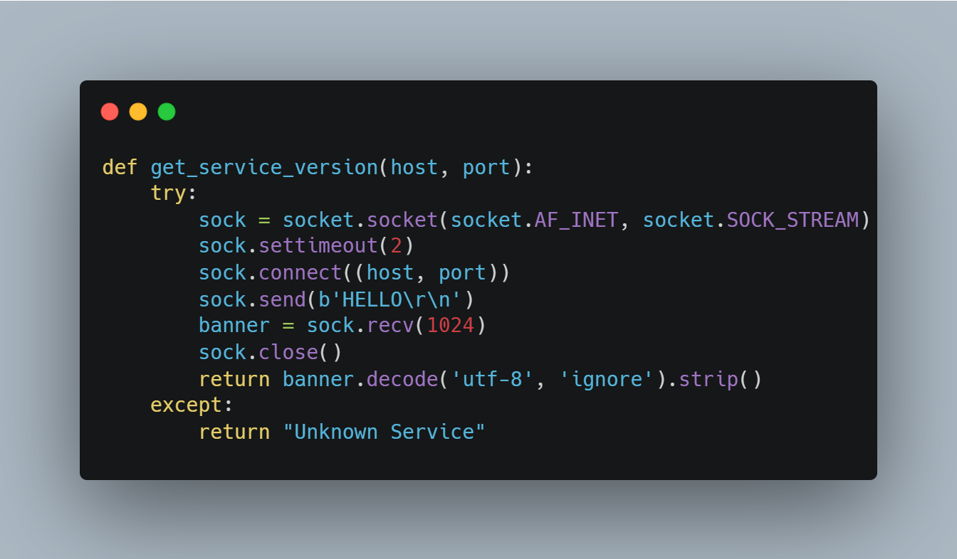

Function detect_os(host)

* **Operating system detection:** Using platform.system(), the function tries to detect the operating system. If it detects Linux, it reports that the OS is Linux.

**For other operating systems**, it returns a message that the

operating system could not be defined.

**Error handling:** If there is an error while trying to determine the Os

an error message is printed.

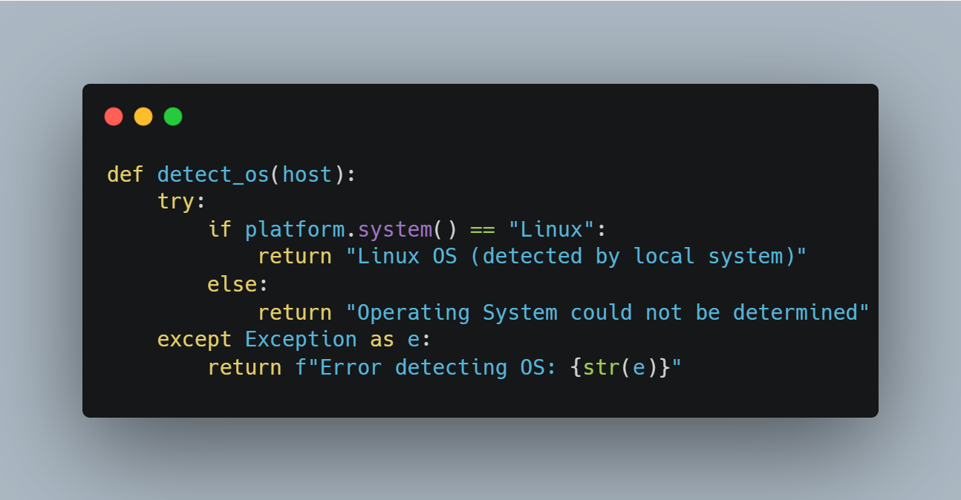

Function scan_ports(host, start_port, end_port)

* **Parallel port scanning**: This function uses the ThreadPoolExecutor to scan ports from start_port to end_port in parallel. This speeds up the scanning process as multiple threads can run concurrently.
* **For each port in the specified range**, the scan_port function is called to check if it is available.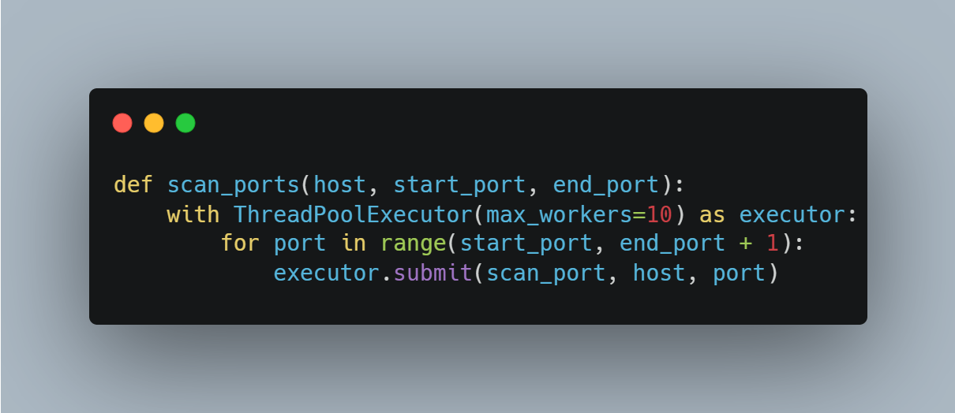

Function start_scan()

* **Receive User Input:** The function asks the user for the host address to be scanned, as well as the port range (start and end).
* **Start scanning**: The scan_ports function starts scanning the ports in the specified range.
* **Detect OS:** After scanning, the host operating system is checked with detect_os and the result is displayed.

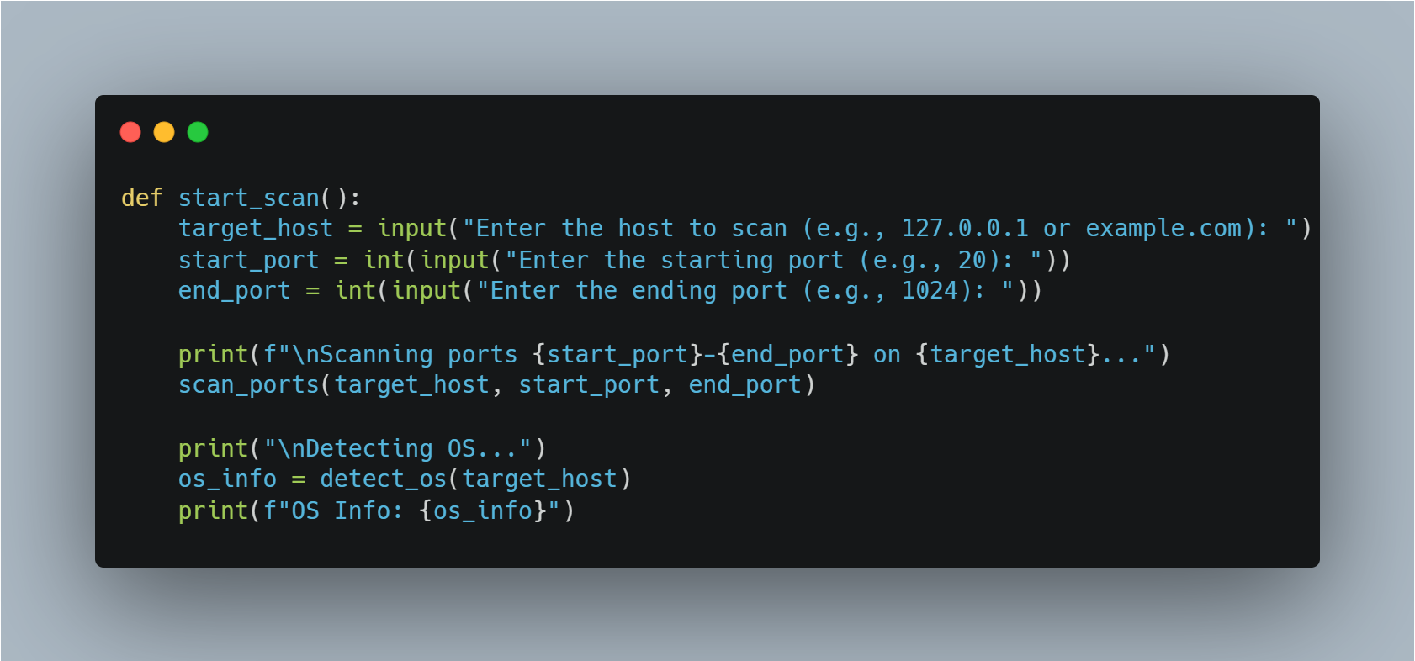

Main Unit if __name__ == "__main__"

**This block ensures that start_scan()** is only called if the script was executed directly, and not imported as a module into another script.

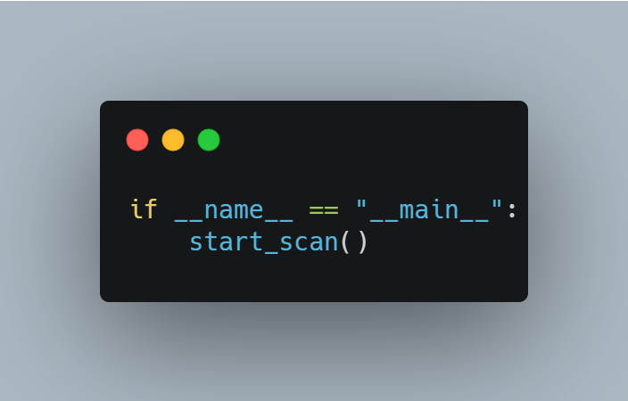

My Nmap scanning 188.114.97.7

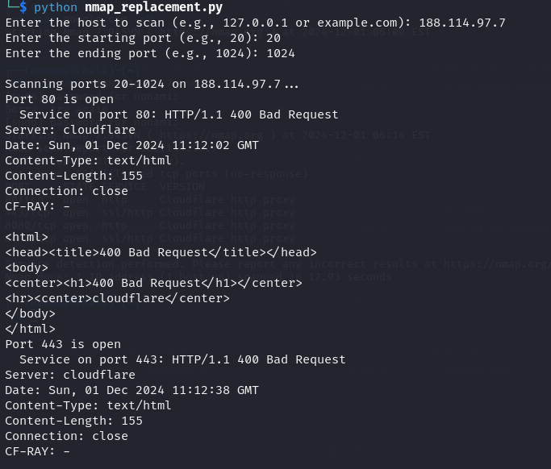

Nmap scanning 188.114.97.7

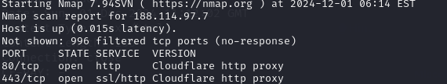

**TryHackMe “Root Me” CTF**

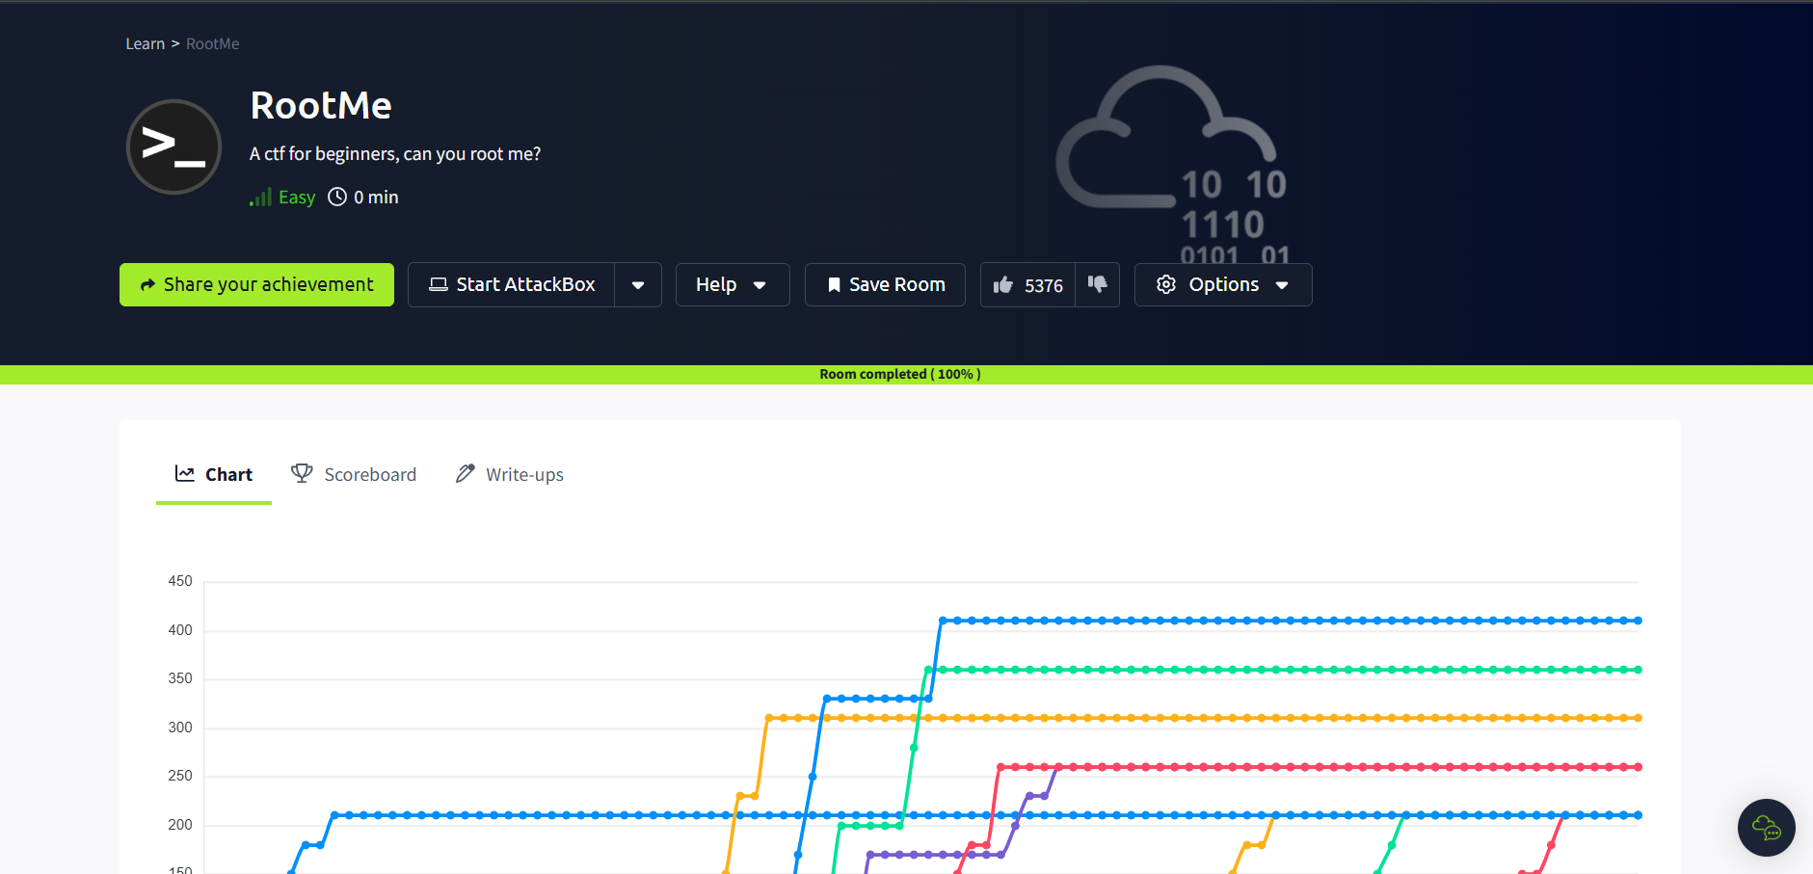

Tryhackme gives us a server to pass the CTF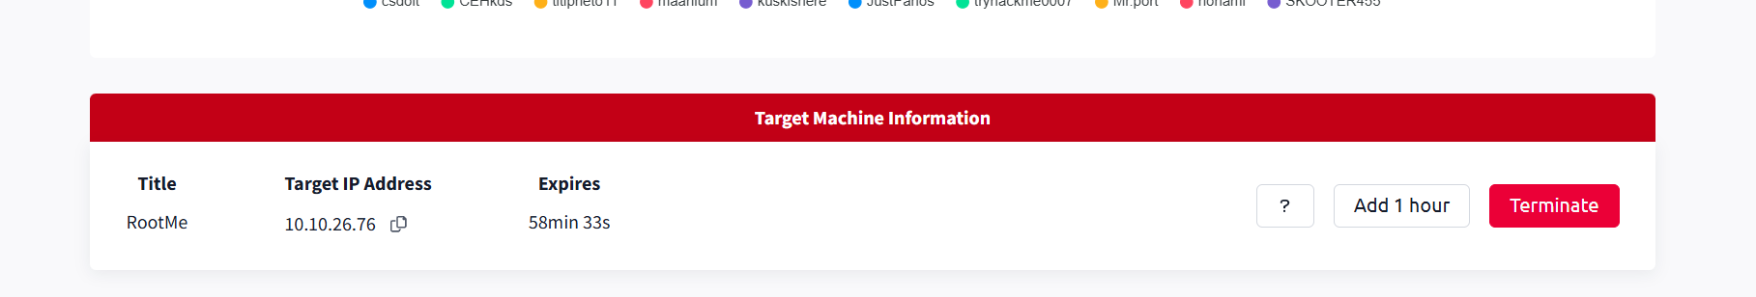

Task 1 **Reconnaissance**

**First, let's get information about the target.**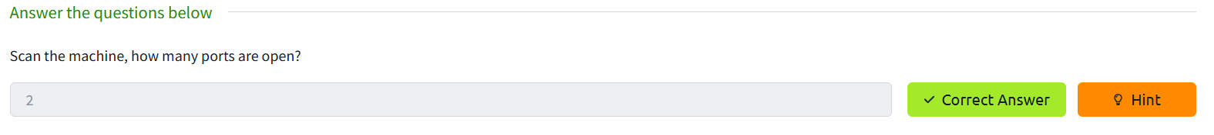

**Scan the server with nmap a and answer the questions.** 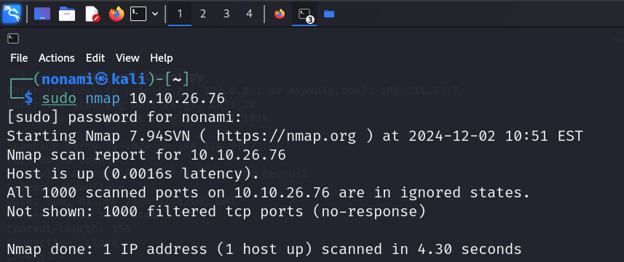

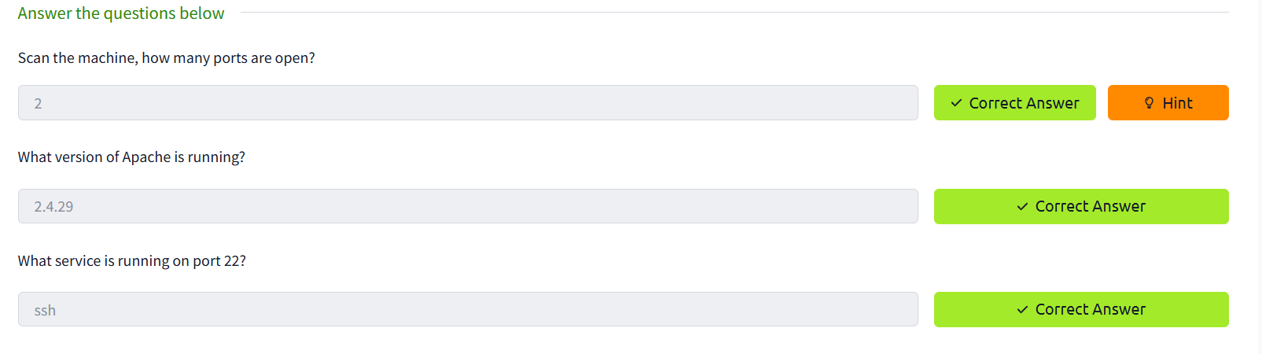

**Answer 2**

Find directories on the web server using the GoBuster tool.

What is the hidden directory?

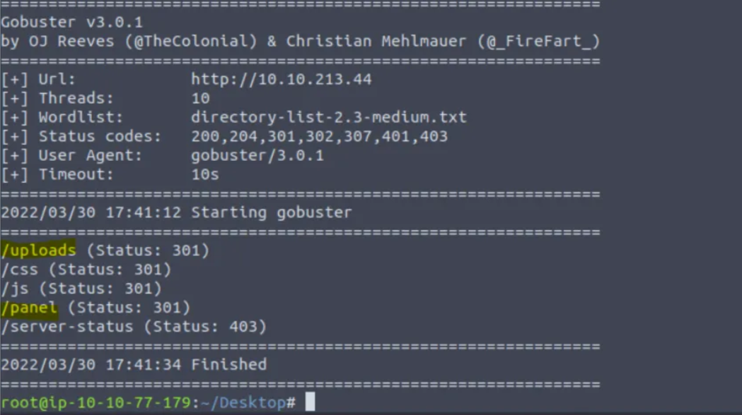

**And answer the questions.**

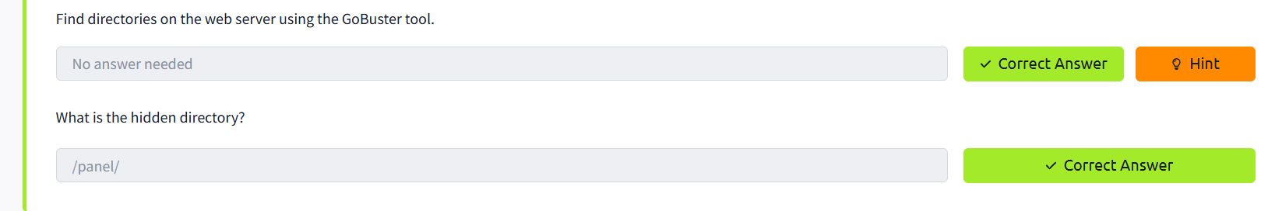

Task 2 **Getting a shell**

**Find a form to upload and get a reverse shell, and find the flag.**

**Find a form to upload and get a reverse shell, and find the flag. In this case we need to go to the ip addres through web browser. The hidden directory named panel will take you to the upload form.**

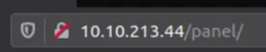

This is my php code. Here we leave port 1234, change only the ip of the attacking machine.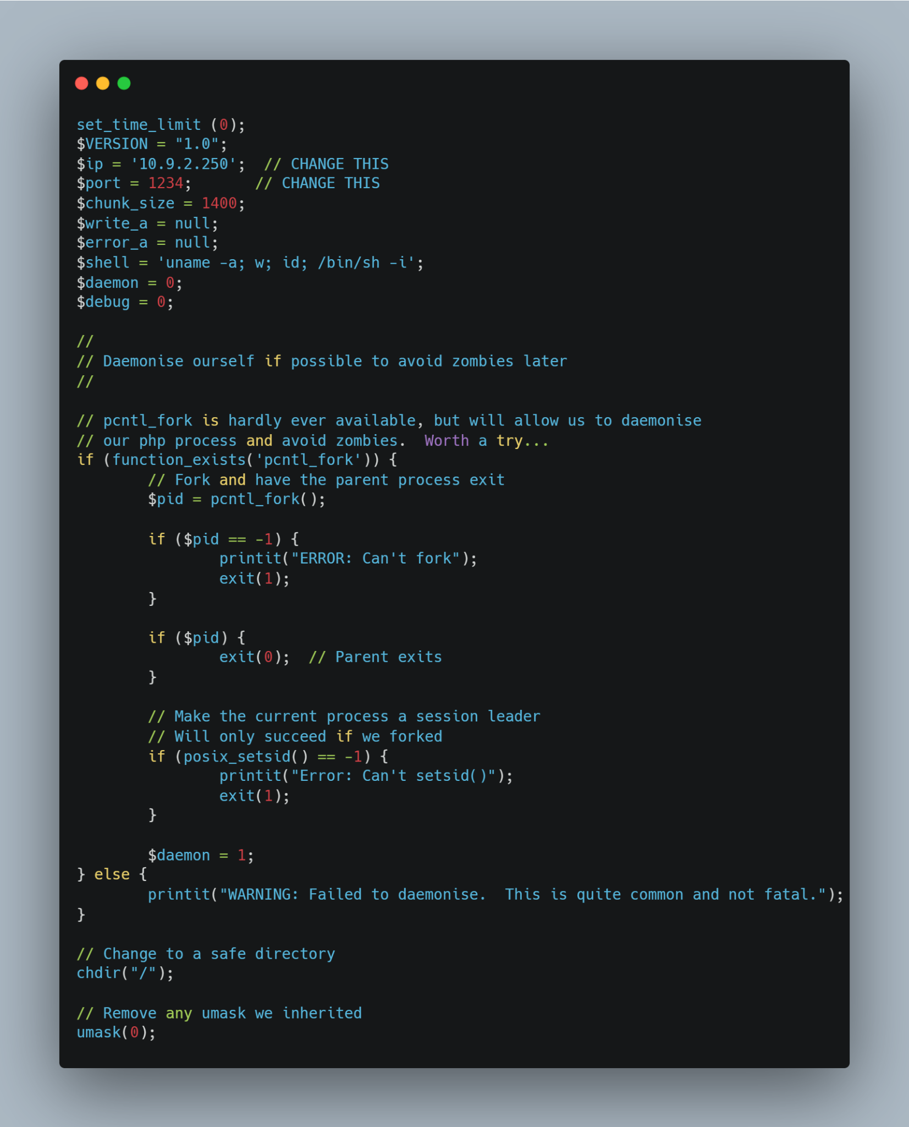

We load our php file and see this result.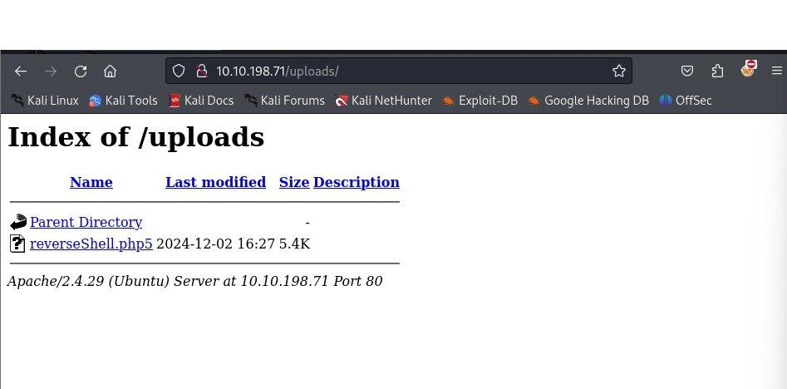

Go to the terminal and type the following commands.

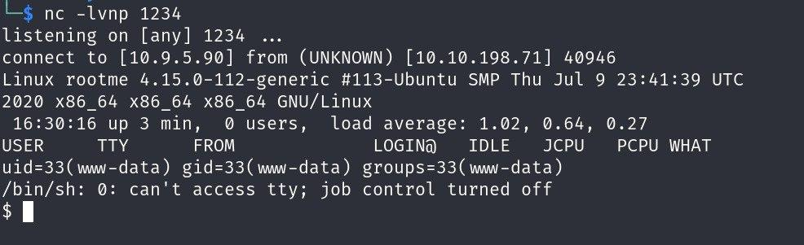

Looking for user.txt

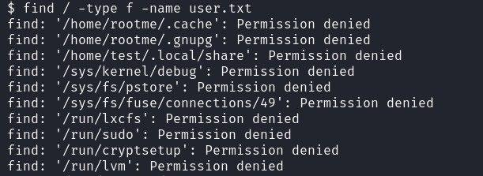

Open user.txt and take the flag.

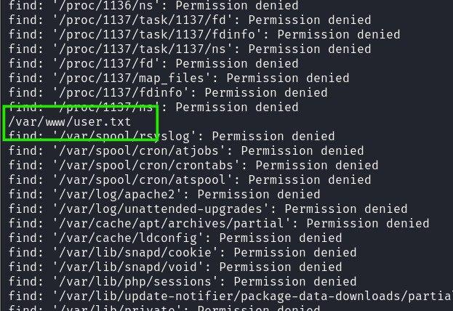

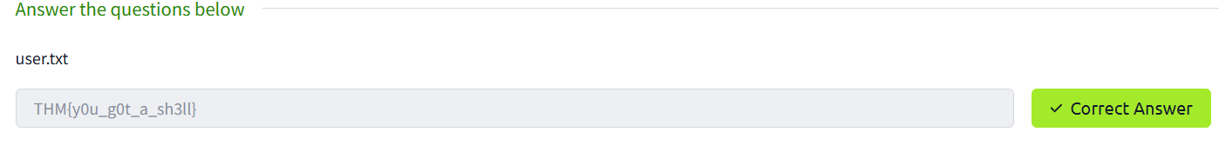

Task 3 **Privilege escalation**

Search for files with SUID permission, which file is weird? We need to run command **find / -user root -perm /4000**. What it means? It is looking for a file with SUID permission that can be run as root. We need to look carefully into the output of the command to find which file can be exploited to gain root access.

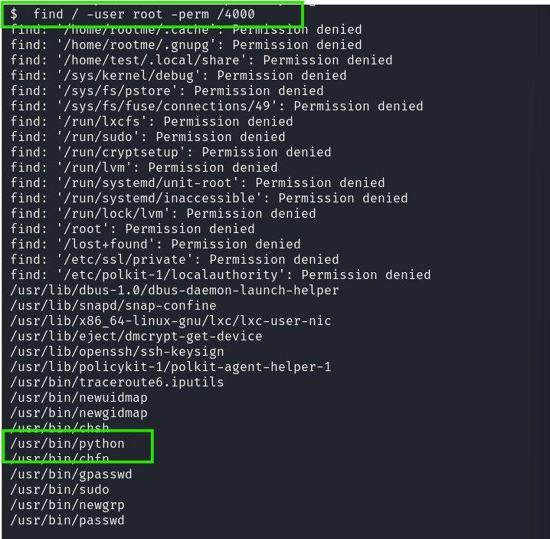

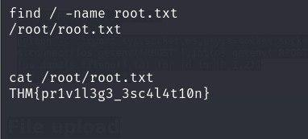

**Tryhackme “PICKLE RICK” CTF**

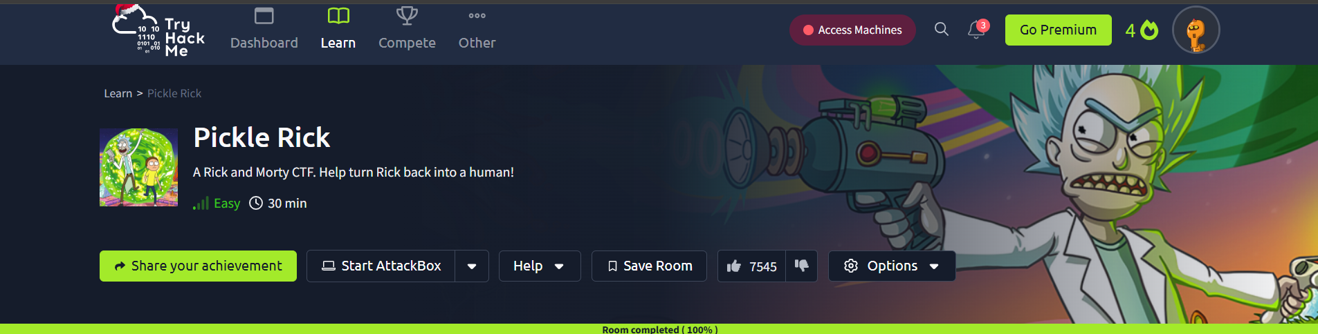

Tryhackme gives us a server to pass the CTF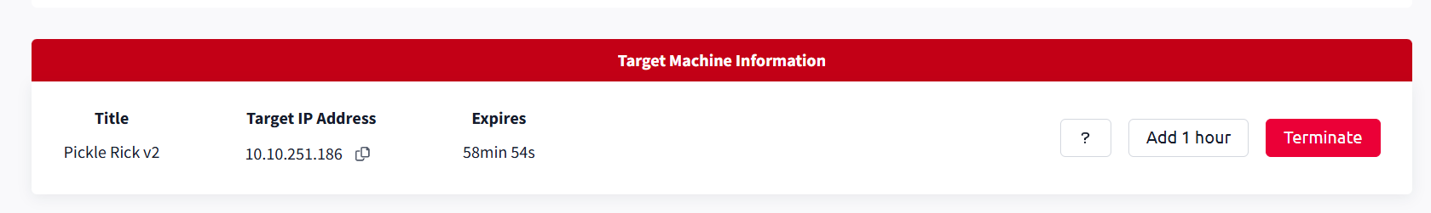

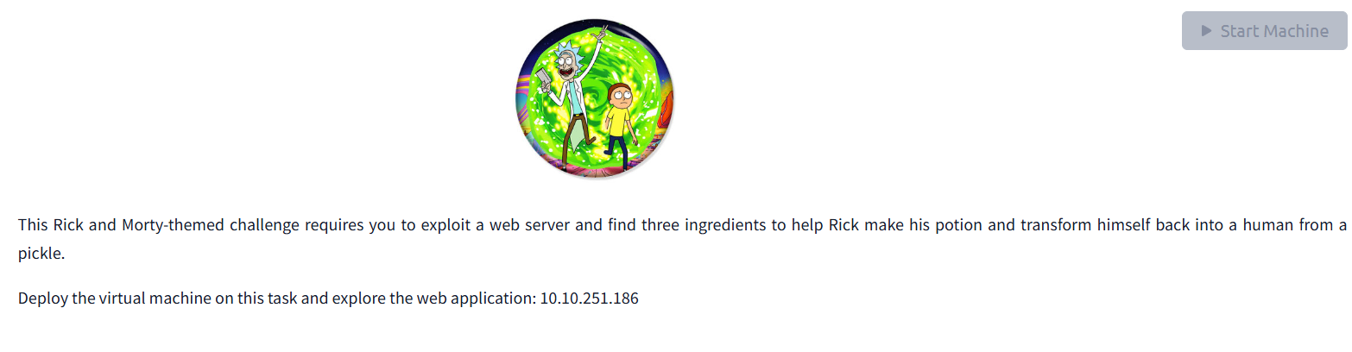

**Answer the Questions**

**Question 1** What is the first ingredient that Rick needs?

To start with, we do a little ***nmap*** scan on the given IP address and discover that there are two open ports as follows :

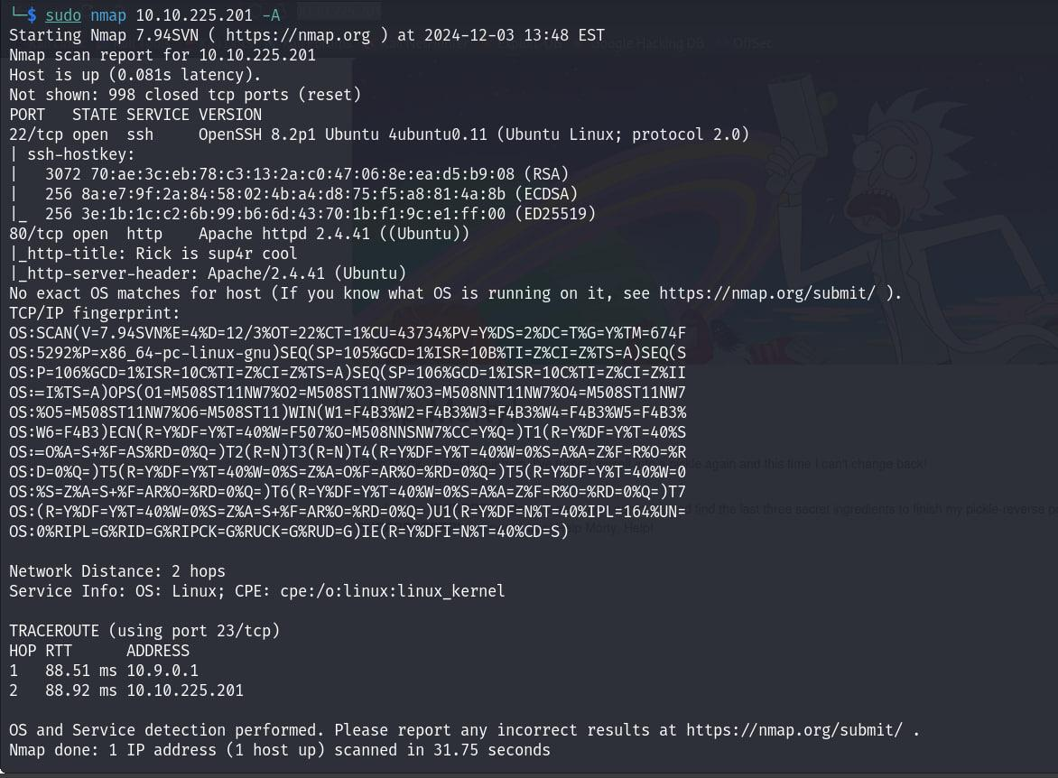

As we don’t have a SSH username and password , we can ignore port 22 for now and hence it leaves us with port 80. We go to ***http://10.10.91.252/*** where we find a page hosted as follows :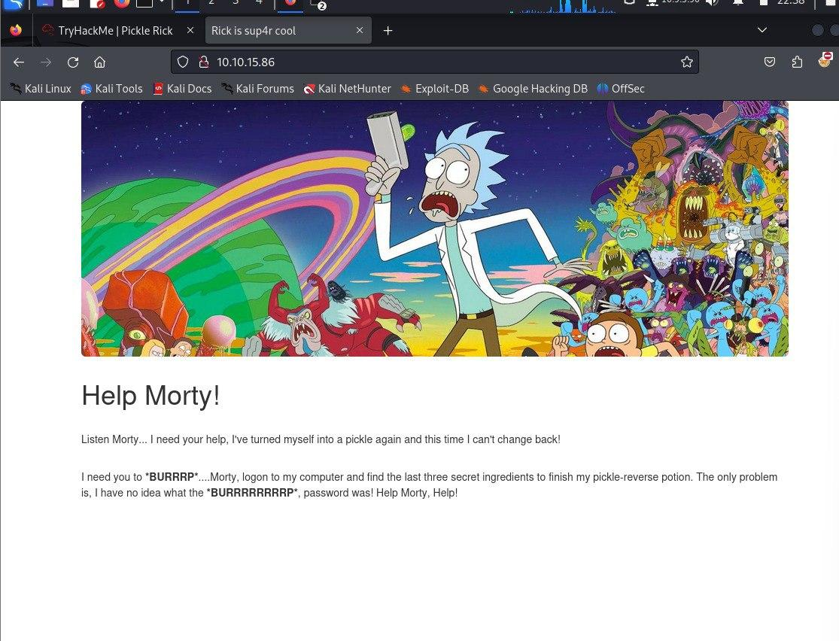

First things first , we view the source code of the page.

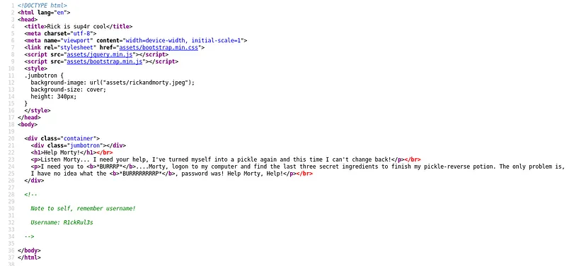

Here we see a little interesting message :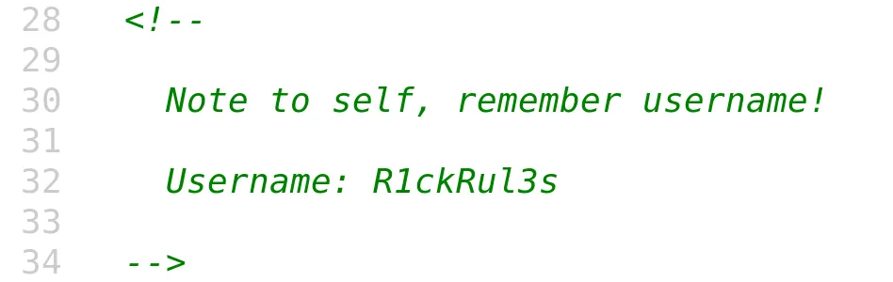

We Find directories on the web server using the GoBuster tool.

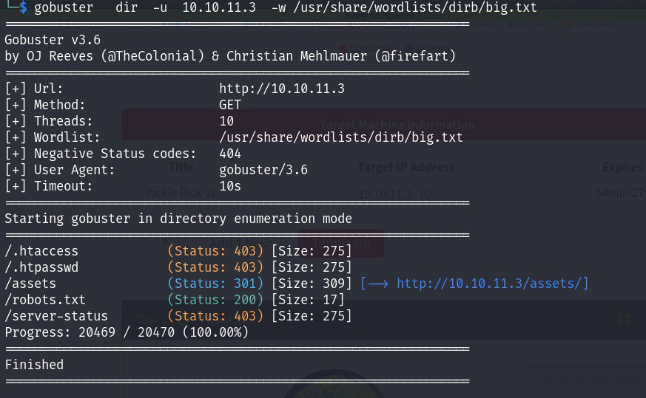

Now if we look again at the files under ***/assets***, we see a***portal.jpg***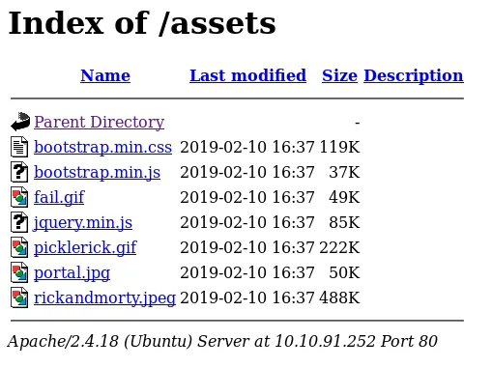

Open /assets hidden directory in browser and download portal.jpg

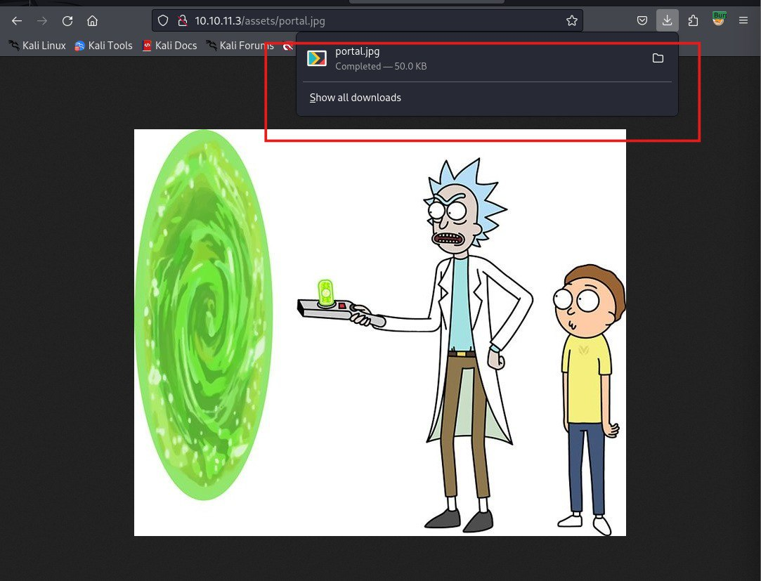

Explore the content of this image by https://exif.tools/ site

So we see that the real format of this image is .php

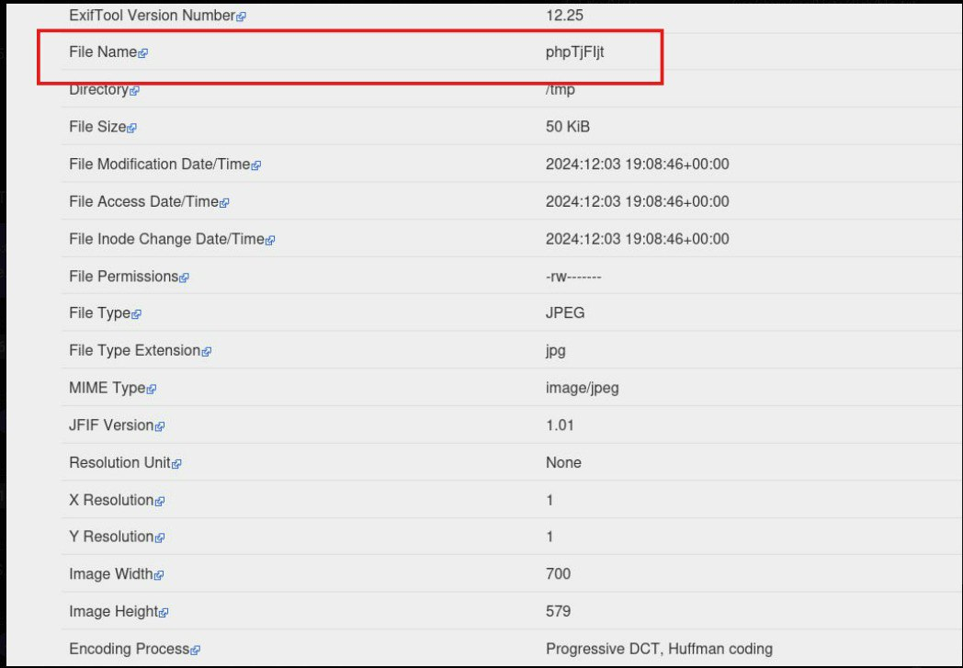

Check for the existence of a robots.txt file. So when I do a curl request to <http://10.10.91.252/robots.txt>

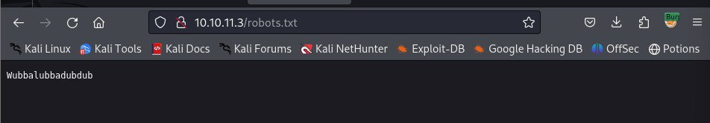

We see that the real format of this image is .php and go <http://10.10.91.252/portal.php>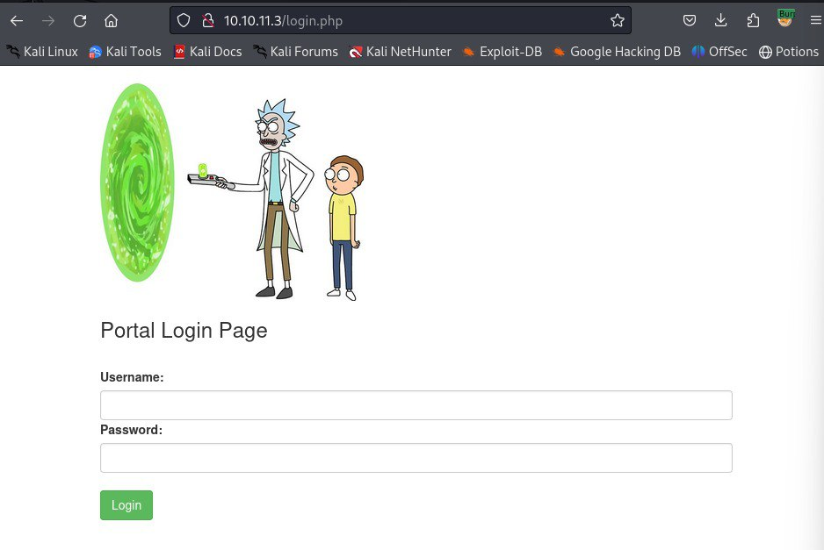

An Username as : R1ckRul3s

A Password as : Wubbalubbadubdub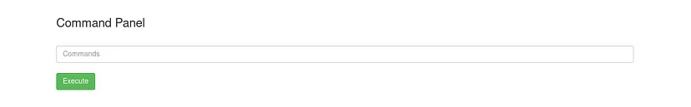

I put in ***ls*** and here we get some the contents of the folder and in there we have our first secret ingredient as ***Sup3rS3cretPickl3Ingred.txt*** !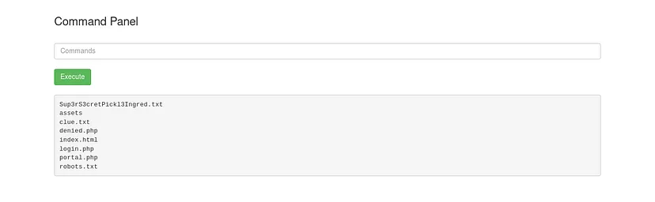

Put in ***less Sup3rS3cretPickl3Ingred.txt*** and we get our First Ingredient !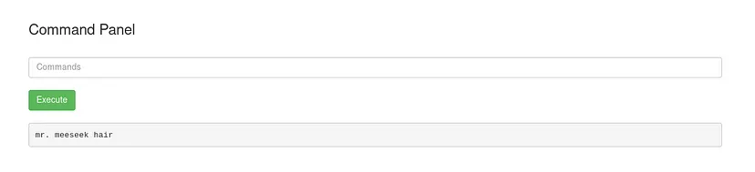

So we found the first ingredient

less clue.txt

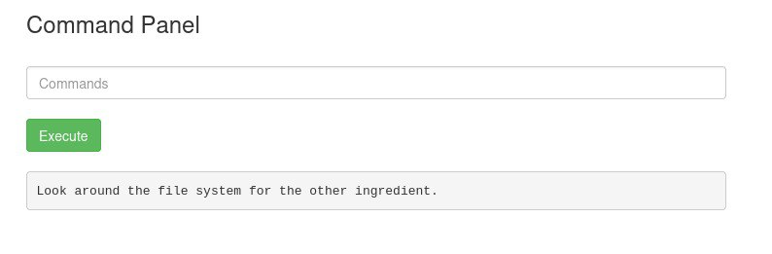

Put in **pwd**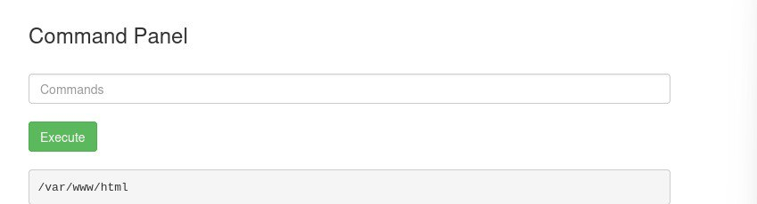

**ls ../../../home**

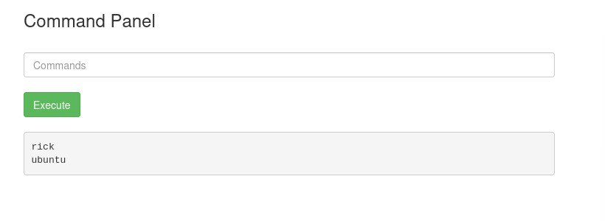

**ls -la ../../../../home/rick/**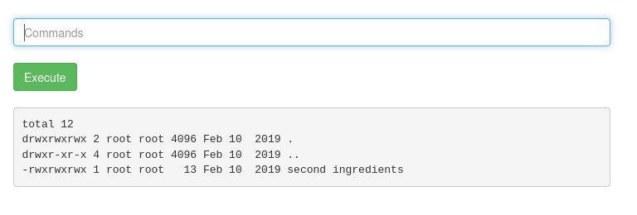

**less ../../../../home/rick/'second ingredients'**

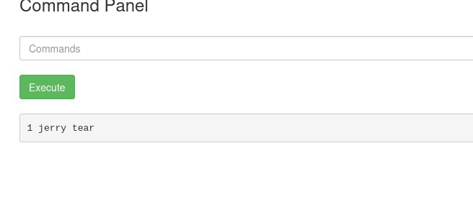

**So we found second ingredient**

**sudo find / -type f -name "*.txt"**

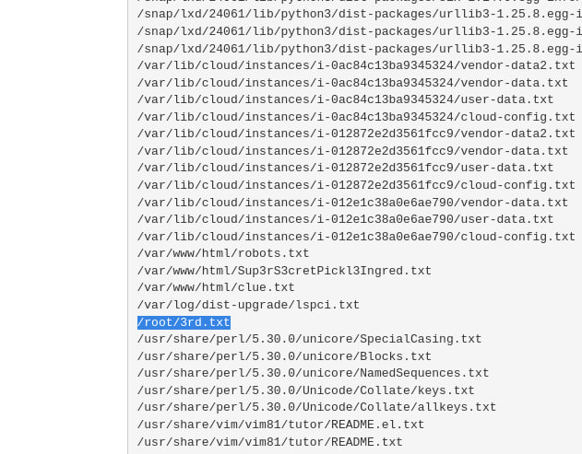

**Using *less* (*sudo less* in case of the third flag)**

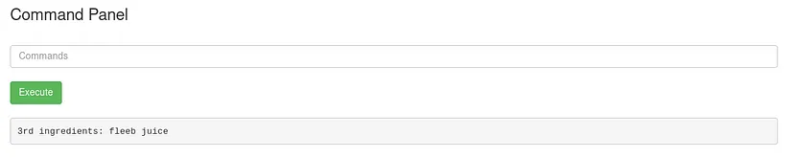

**Tryhackme “Mr. Robot” CTF**

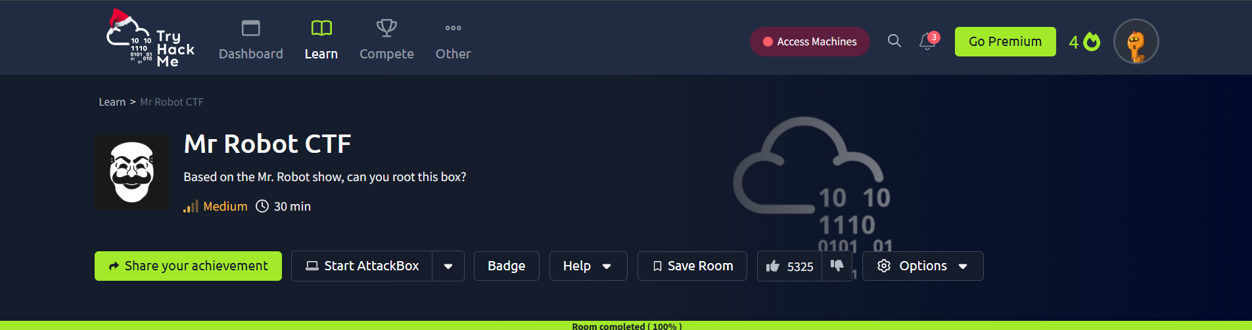

Tryhackme gives us a server to pass the CTF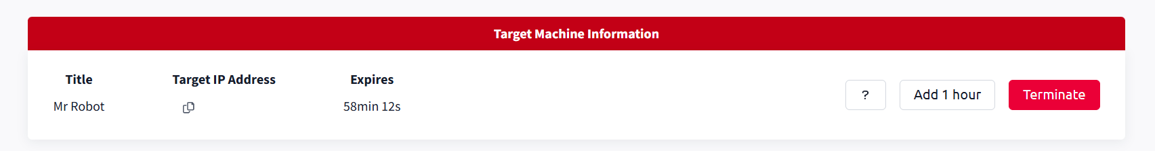

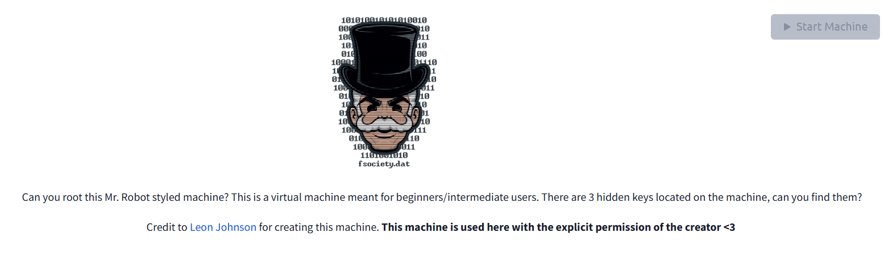

# **Reconnaissance**

I used nmap to scan the target host and discovered that ports 80 and 443 were open. This indicated a web server, which was a good starting point.

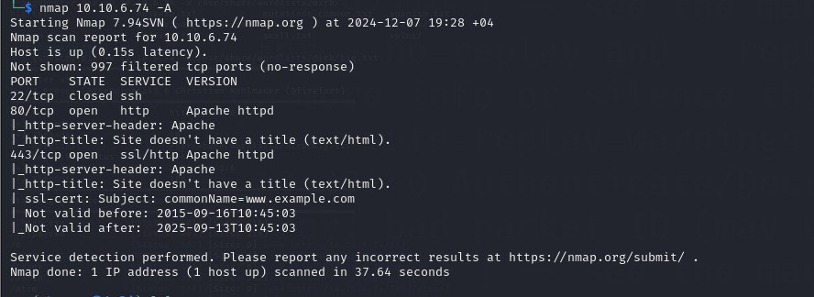

Using gobuster, I discovered robots.txt, which concealed the first key and fsocity.dic. Further scanning with gobuster revealed the page /dashboard, which pointed to a WordPress login, and also discovered /license, where scrolling down the page revealed a base64 encoded string.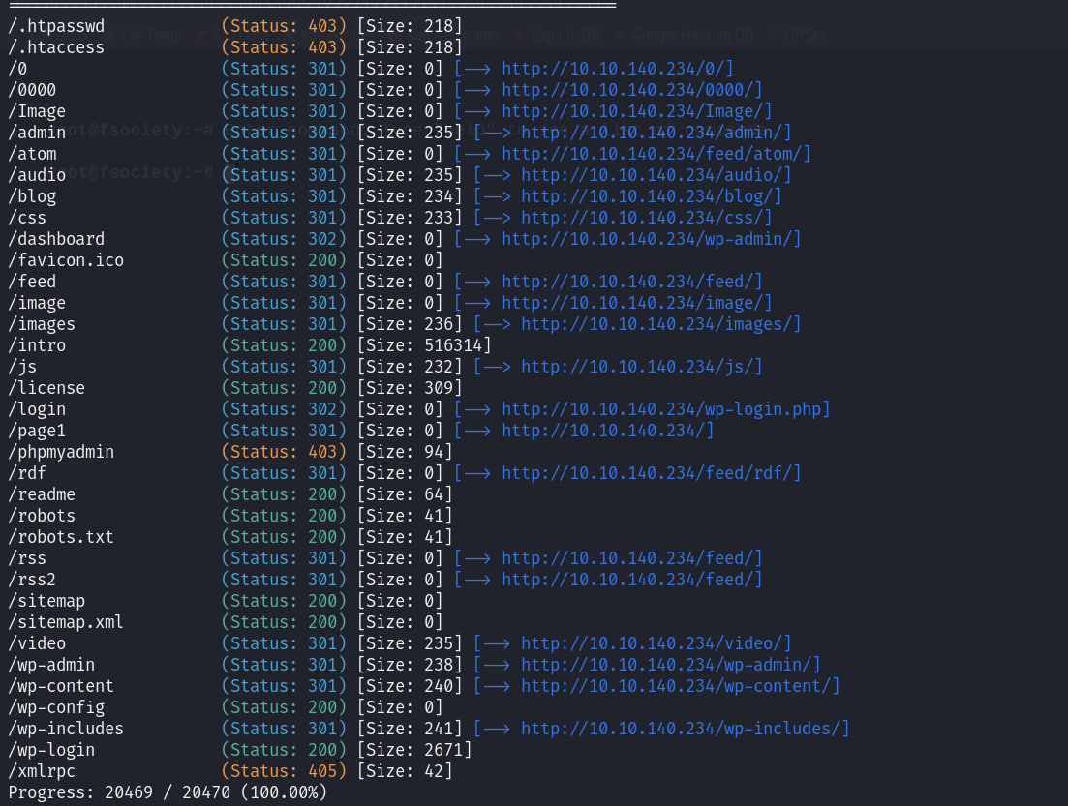

# **/robots**

User-agent: *

fsocity.dic

key-1-of-3.txt



**/80**

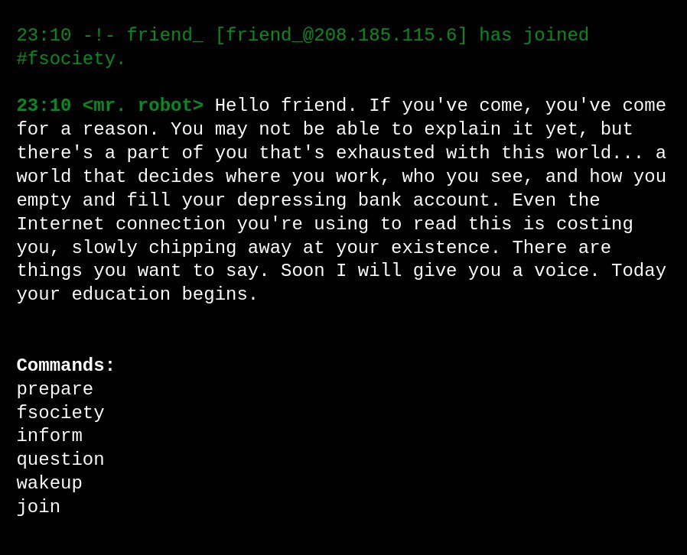

# 

# **/dashboard**

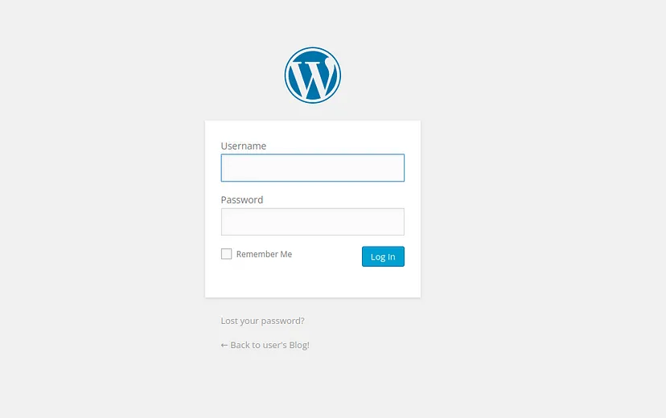

# **/license**

scroll down ZWxsaW90OkVSMjgtMDY1Mgo=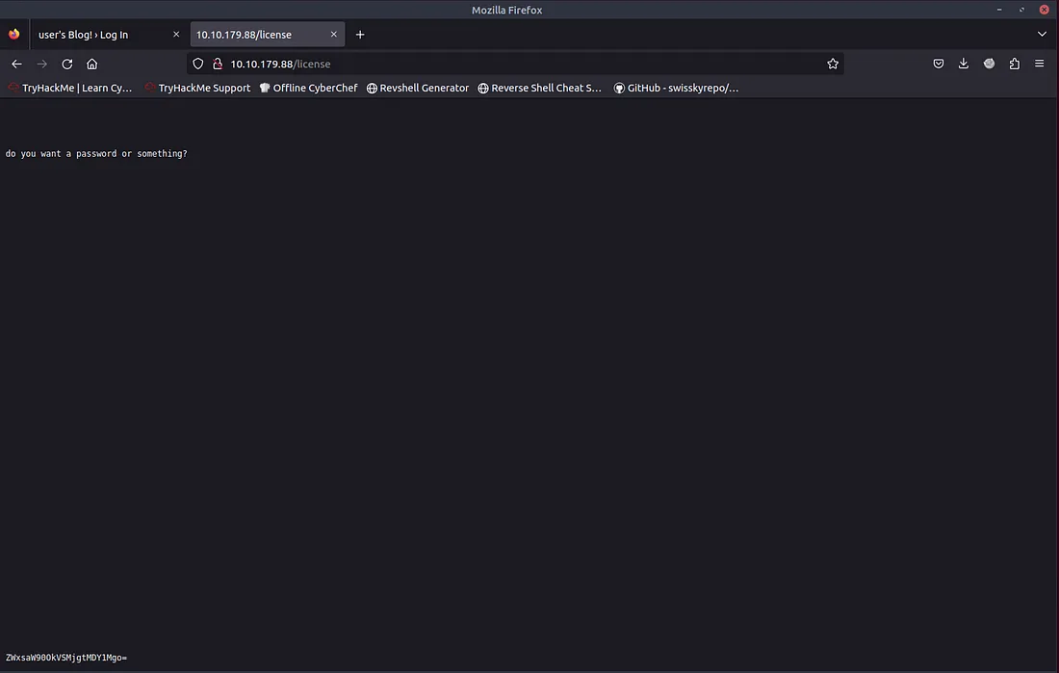

I decoded the base64 string, obtained a password, and logged into the WordPress admin panel.

ZWxsaW90OkVSMjgtMDY1Mgo=

base64 decoder > elliot:ER28–0652

# **/dashboard**

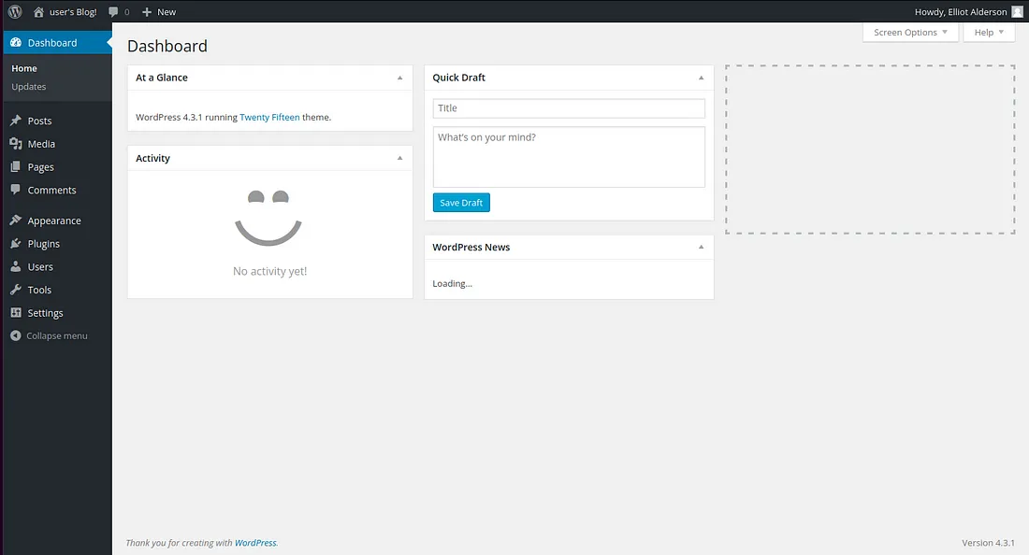

Here, I modified the 404 page to contain a reverse-shell. I launched netcat and opened the 404 page, which granted me a shell.

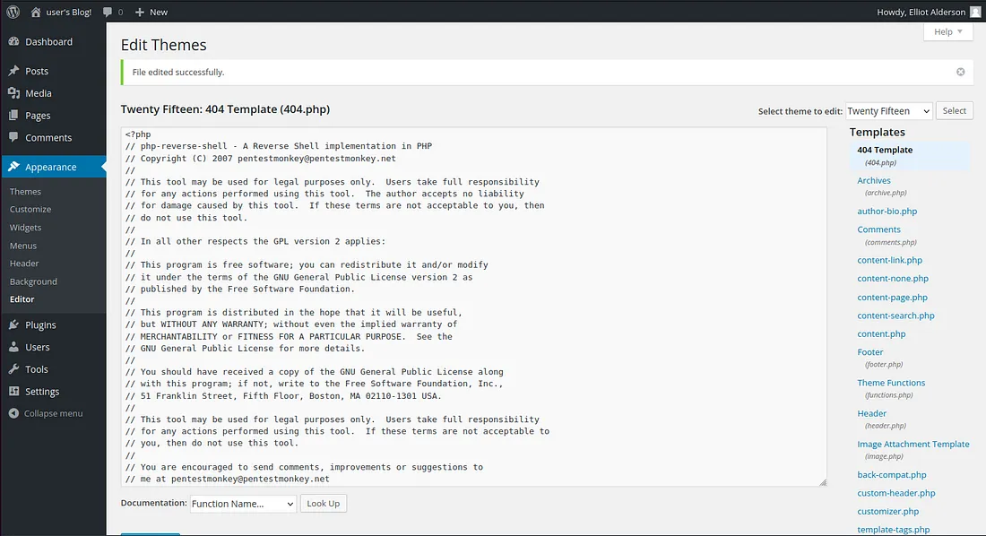

run nc and visit page

nc -lvnp 1234

# **Shell time**

The shell was under user daemon. In /home/robot, I found the second key file, but it was only accessible to the user robot. However, the file password.raw-md5 was accessible, and using CrackStation, I managed to obtain the password from the MD5 hash.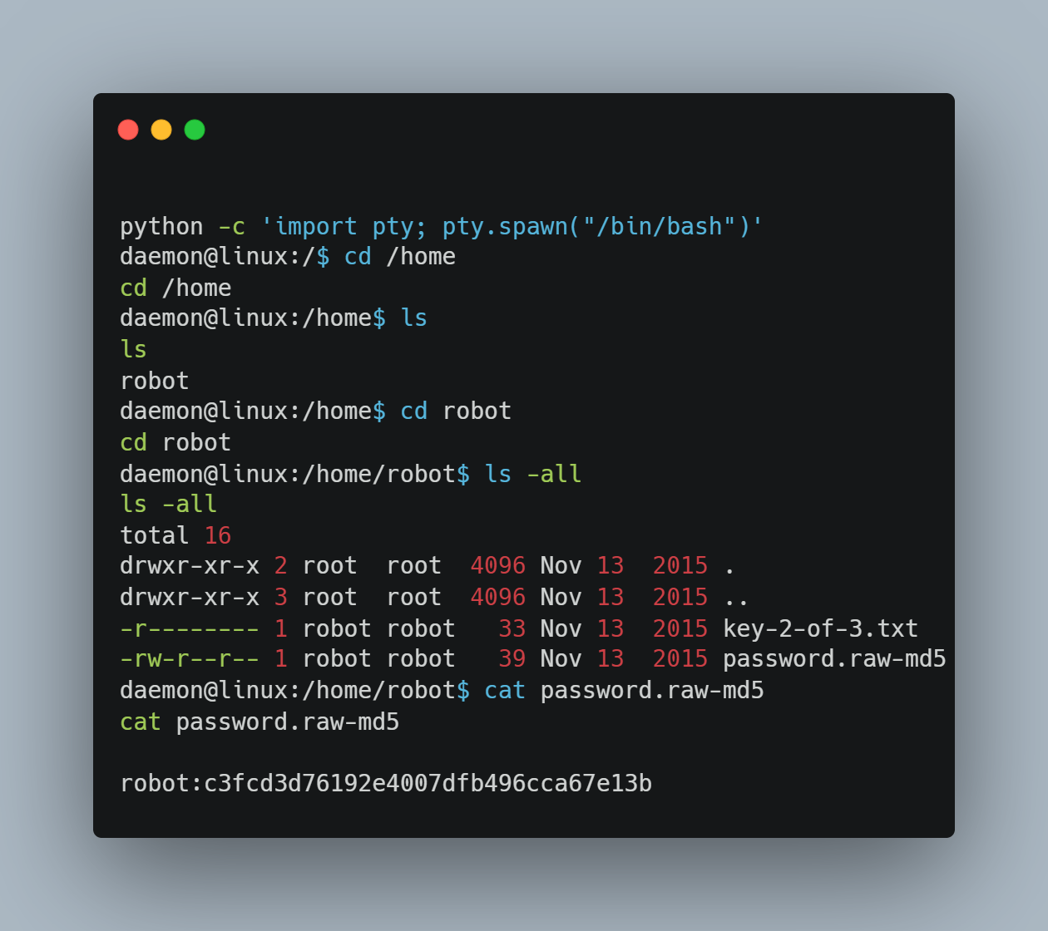

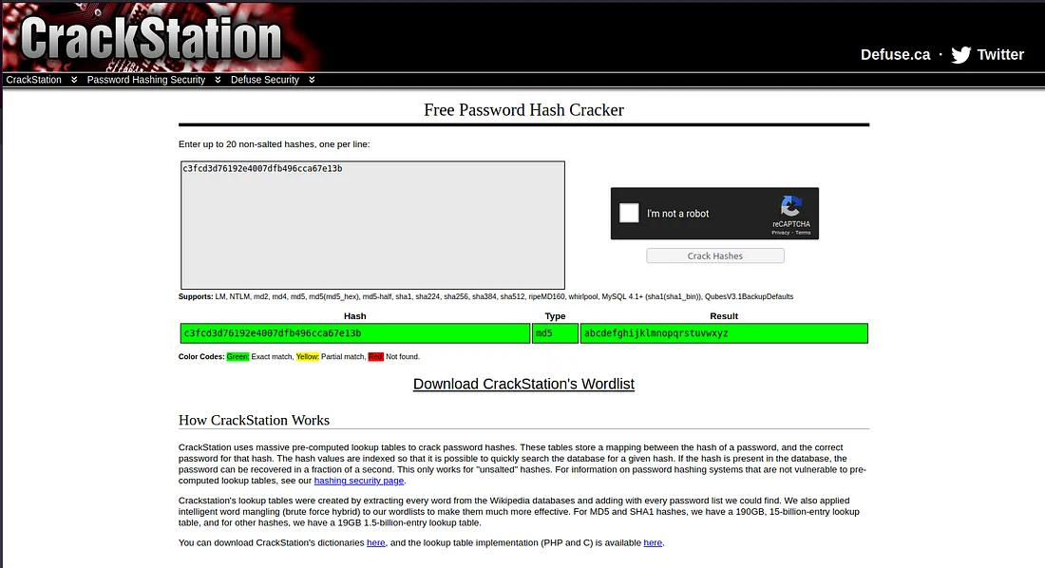

***abcdefghijklmnopqrstuvwxyz***

I utilized the password to switch to the user robot, thereby acquiring the second flag.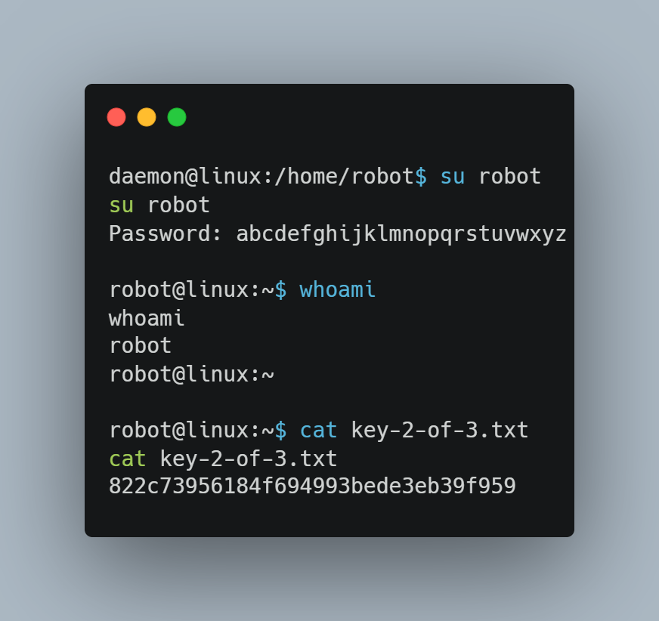

# **Privilege Escalation**

Now, it was necessary to perform privilege escalation to gain root access and open the root flag.

Following a guide on GTFOBins, I found out how to exploit nmap for sudo privileges, became root, and obtained the root flag.

GFOBin -> <https://gtfobins.github.io/gtfobins/nmap/#sudo>

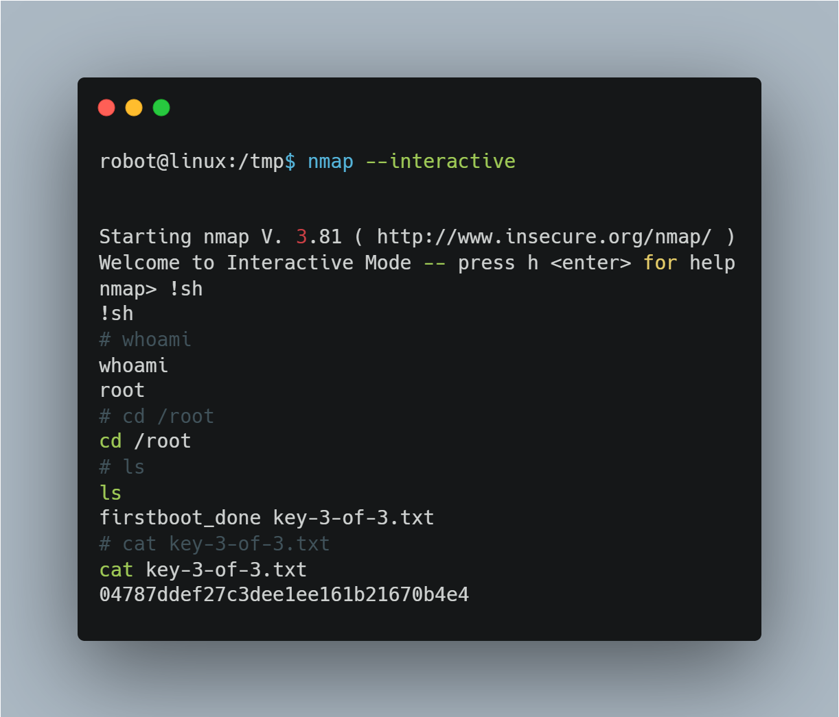

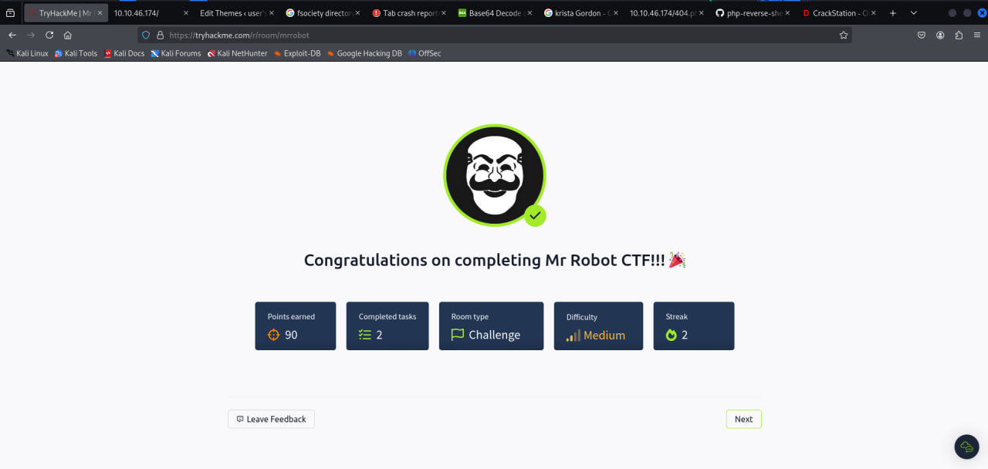

**Gobuster Universal Script**

